Translation from the Lithuanian language

STATE ENTERPRISE
IGNALINA NUCLEAR POWER PLANT
PROJECT MANAGEMENT DEPARTMENT
CONSTRUCTION ORGANIZATION AND DEMOLITION PROJECTS DIVISION

APPROVED BY
Director of PMD
(Approved with an unqualified e-signature)
______________
Dmitrij Jekateriničev

TECHNICAL TASK FOR THE PROCUREMENT OF WORKS RELATED TO THE CONSTRUCTION OF THE INPP NEAR SURFACE REPOSITORY FOR LOW- AND INTERMEDIATE-LEVEL SHORT-LIVED RADIOACTIVE WASTE (CONSTRUCTION STAGES I/A, II/A) AND DESIGN, CONSTRUCTION AND CONNECTION OF THE EXTERNAL RAINWATER DRAINAGE NETWORKS TO THE INPP INFRASTRUCTURE

<Dok. data> No. <Reg. Nr.>
Visaginas

CHAPTER I
TYPE OF PROCUREMENT
- Procurement of construction works.
  - Type of construction:
construction of a new building (procurement of construction works according to the technical design ‘B25-1 – Near Surface Repository for Low- and Intermediate-Level Short-Lived Radioactive Waste at Stabatiskės vlg., Visaginas Municipality, Construction Project’ (I/A, II/A construction stages) (hereinafter – the Repository);
construction of new engineering structures (works on construction of external rainwater drainage networks and their connection to the infrastructure).
  - Construction works to be procured:
Repository, including design services (Detailed Design);
external rainwater drainage networks, including design services and supervision of the Engineering Detailed Design (EDD) implementation (procurement of design services for the external rainwater drainage networks which are to be laid from the design boundary of the Repository as indicated in this Technical Task (hereinafter – TT) to the connection points of the external rainwater drainage networks as indicated in the TT).
CHAPTER II
OBJECTIVE
- The objective of this TT is to procure the Repository design services for I/A and II/A construction stages (preparation of the DD for the Repository I/A and II/A construction stages) and the Repository I/A and II/A stage construction works; as well as the design services for the Repository external rainwater drainage networks (preparation of the EDD) and the EDD implementation supervision services, works on construction and connection of these networks to the infrastructure.
CHAPTER III
INFORMATION ON THE FACILITY WHERE CONSTRUCTION WORKS ARE TO BE CARRIED OUT
- Since some of the Repository’s systems and components are assigned to the 3rd safety class, the procured works are considered as a safety related product. The detailed classification of the systems and components is provided in the Technical Design and Preliminary SAR of the Repository. The Repository is designed for the placement of packaged short-lived low- and intermediate-level radioactive waste (Class B and C waste according to BSR-3.1.2-2017 ‘Regulation on the Predisposal Management of Radioactive Waste at the Nuclear Facilities’).
- The Repository must be constructed on the site whose cadastral No. is 4535/0002:27 (unique No. 4400-2111-0830) (hereinafter – the Site), to the south of the INPP. The location of the site and the layout of the facilities located on the site are indicated in Annex 2 to the TT.
- The construction site of the Repository is deforested, tree stumps are not removed, the major part of the area is covered with bushes and trees. A part of the territory is swampy, water bodies are located near road No. 4. The site is undeveloped, the relief is hilly. Road No. 3 located in the western part of the site coincides with road of regional significance No. 177. The geological and hydrological conditions of the Repository site are described in detail in documents 1-7 of Annex 1 to this TT.
- The Technical Design of the Repository ‘B25-1 – Near Surface Repository for Low- and Intermediate-Level Short-Lived Radioactive Waste at Stabatiskės vlg. Visaginas Municipality, Construction Project’ No. SM1301P25 was developed by the partners CJSC “Specialus montažas-NTP”, ANDRA, Lithuanian Energy Institute, the leader of Joint Venture Partnership is CJSC “Specialus montažas-NTP” (Visaginas, Lithuania) (see the document in Item 1 of Annex 1 to the TT).
- The Preliminary Safety Analysis Report ‘Project B25-1 – Near Surface Repository for Low- and Intermediate-level Short-lived Radioactive Waste (Design)’, B25-1/S/14-1129.9.12/PSAR-DR1/R:3 was prepared by the Lithuanian Energy Institute (Kaunas, Lithuania) (see the document in Item 2 of Annex 1 to the TT).
CHAPTER IV
ABBREVIATIONS AND DEFINITIONS
- The following abbreviations are used in the TT:
JSC, CJSC – Joint Stock Company (JSC), Closed Joint Stock Company (CJSC);
ANDRA – French National Radioactive Waste Management Agency;
NF – Nuclear Facility;
BSR – Nuclear Safety Requirements;
DD – Detailed Design;
DMSD – Decommissioning Management System and Database;
FIDIC – International Federation of Consulting Engineers;
INPP – SE Ignalina Nuclear Power Plant, Employer (Constructor);
INPP SU – INPP Security Unit;
IEC – International Electrotechnical Commission;
c. d. – Calendar days;
SRW – Solid radioactive waste;
KTR – Technical Regulations for Roads;
LR – The Republic of Lithuania;
MTR – Technical Regulations for Reclamation;
SW – Software;
SAR – Safety Analysis Report;
SSC IS – NF Structures, Systems and/or Components Important for Safety;
STR – Construction Technical Regulation;
EDD – Engineering Detailed Design;
TD – Technical Design ‘B25-1 – Near Surface Repository for Low- and Intermediate-Level Short-Lived Radioactive Waste at Stabatiškės vlg., Visaginas Municipality, Construction Project’ No. SM1301P25;
TT – Technical Task;
VATESI – State Nuclear Power Safety Inspectorate;
SE – State Enterprise.
Repository site – the Repository site and adjacent territories that could be affected by the planned activities.
NF site – a territory with set boundaries where nuclear facility construction works are conducted, where a nuclear facility is already constructed and operated, or where its decommissioning or surveillance of the closed Repository is conducted.
Controlled area – an area subjected to the requirements of special regulations for protection against ionising radiation or radioactive contamination, and the access to which is under supervision.
Safety related product – a product, service, software program supplied and (or) produced in-house, documents developed or works performed, whose non-compliance with the product requirements stipulated in the technical documents, procurement documents, legislation and/or nuclear safety regulatory technical documents may affect safety.
Supplier of a safety related product – an individual or a group of individuals cooperating with the organisation, who are not employed by the organisation and who can supply or already supply a product, including all the subcontractors/subsuppliers of the Supplier cooperating with the organisation that are contracted by the Supplier cooperating with the organisation for implementation of its contractual liabilities.
Contract – a contract agreement on the construction of the INPP Near Surface Repository for Low- and Intermediate-level Short-lived Radioactive Waste (construction stages I/A, II/A) and design, construction and connection of the external rainwater drainage networks to the infrastructure.
Technical measures of the physical protection system– technological equipment ensuring the control of access to the sources, detection of unauthorised access to the sources, quick and reliable transmission of information and its assessment, as well as physical barriers protecting against accidental or unauthorised access to the sources by random persons, their theft or sabotage.
CHAPTER V
DESCRIPTION AND SCOPE OF DESIGN AND CONSTRUCTION WORKS
- When drafting the proposal, the Contractor must analyse in detail the documents of this procurement and the documents indicated in this TT Annexes, and in compliance with them the Contractor must:
  - Provide for sufficient quantities and scopes of research required to prepare the DD and EDD.
  - Assess all the risks related to other Repository works, services and goods (design, construction, installation, supply, individual tests and construction completion of the external infrastructure – external technological road from point T.1 to point T.3, see Annex No. 2 of the TT, external 6 kV power supply, electronic communications networks, boiler-house and other structures, equipment, systems and components, as well as other works, services and goods (see Annex No. 3 of the TT), which are not in the scope of this procurement, and will be provided by other Employer’s contracted Contractors and Suppliers.
  - Evaluate technical, financial and all other aspects of optimization solutions indicated in Annex No. 8 of the TT (i.e. to include optimization solutions’ costs into a proposal) and submit a proposal covering assessment of the mentioned optimization solutions, that the Contractor plans to implement, as well as the costs of their implementation (except for the cost of the Technical Design changes). Increase in costs of optimization solutions during the execution of the Contract is the Contractor’s responsibility.
  - Assess all costs and time expenditures for coordination of the proposed technical solutions and consider possible changes in the quantitative and qualitative characteristics of the system during the coordination. Also, assess the changes in the quantities of works, materials, and all other related quantities in the parts of the TD related to the requirements of clause 10.8 of this TT.
- While implementing the requirements of this TT, the Contractor must:
  - In accordance with the requirements of the Procedure for Safety Related Products’ Suppliers and Sub-Suppliers’ Assessment and Their Activities Control at SE INPP, DVSta-1708-4, the requirements set in the procurement documents, and based on ISO 10006 or equivalent standard, the Contractor must prepare and agree the Contract Quality Assurance Plan and the Project Management Plan with the FIDIC engineer no later than within 42 calendar days from the entry into force of the Contract (before commencement of works). Upon entry into force of the Contract, the Contractor (and subcontractors and subsuppliers of all levels) can start performing contractual obligations only after having properly prepared, agreed and submitted the Quality Assurance Plan to the FIDIC engineer. The Contractor will have to comply with these plans throughout the construction period.
  - Based on the requirements specified in the Procedure for Safety Related Products’ Suppliers and Sub-Suppliers’ Assessment and Their Activities Control at SE INPP, DVSta-1708-4, the Quality Assurance Plan shall integrate:
    - Detailed Schedule for services, delivery of goods and performance of works (hereafter – the Schedule). The Schedule (including its updates) must be prepared in accordance with the requirements of item 12 of the TT;
    - Detailed Plan of inspections and tests (including all studies) with all data requested in Annex 1 of the Procedure for Safety Related Products’ Suppliers and Sub-Suppliers’ Assessment and Their Activities Control at SE INPP, DVSta-1708-4;
    - The Quality Assurance Plan must provide for management system audits of all suppliers who are actually delivering a safety related product.
  - Prepare and agree with the FIDIC engineer the DD for stages I/A and II/A in accordance with the requirements set out in this TT and the contract agreement in order to perform the Repository I/A and II/A construction stage works. The DD can be prepared as an integral document in one instalment or can be divided into the DD parts as specified in the Construction Technical Regulations STR 1.04.04:2017 ‘Building Design, Design Expertise’. If the Contractor decides to divide the DD into parts, its prepared Schedule shall integrate timelines for development, agreement, expertise and submission to the FIDIC engineer of the DD parts as well as all other timelines related to the DD development.
  - Perform all site preparation works (remove tree stumps, bushes and existing trees, carry out vertical site levelling, etc.) at the Repository site and the construction site for the Repository’s external rainwater drainage networks designed by the Contractor;
  - Carry out all I/A and II/A construction stage works, provide the services, supply and install all the necessary equipment envisaged for I/A and II/A construction stages in accordance with the Repository TD, DD, contract agreement (including the TT), except for the works, services, materials and equipment listed in Annex 3 to the TT;
  - Conduct all necessary research required for design preparation, construction implementation and completion according to the requirements set out in STR 1.04.04:2017 ‘Building Design, Design Expertise’, STR 1.04.02:2011 ‘Engineering Geological and Geotechnical Surveys’ and the Repository TD prior to the start of preparation of the Repository DD, EDD for external rainwater drainage networks as well as during construction;
  - Based on the requirements established in the TT and in the contract agreement as well as based on the conditions and requirements provided by ESO and LITGRID, prepare, agree with the FIDIC engineer, ESO and LITGRID as well as submit to the FIDIC engineer the EDD for the section of the Repository’s external rainwater drainage networks that will connect the Repository’s and the existing INPP rainwater drainage networks (including preparation of the construction cost estimation part). Prior to preparation of the EDD, prepare design proposals, correct them, if necessary, and take part in (a) public information meeting (-s) as envisaged in STR 1.04.04:2017 ‘Building Design, Design Expertise’. During preparation of the EDD, the Contractor must avoid and/or reduce as much as possible or, if possible, completely avoid reconstruction (relocation) and/or modernization of ESO and LITGRID operated electric power networks and other equipment, systems and components. The requirements and conditions of ESO and LITGRID must be satisfied in case of failure to avoid intersections with the existing networks. The Contractor shall foresee and arrange ditches of appropriate depth to ensure proper natural water drainage from the Repository site.
  - When preparing the DD, the Contractor shall:
    - Foresee that the section of the technological road, designed in the TD (see TT Annex 9, points T.1, T.2), together with another section of this technological road, not designed in the TD (see TT Annex 9, points T2, T3), will be constructed in accordance with another Contractor’s developed design and are not part of the scope of this procurement;
    - Foresee that structure 14 – a fuel filling site – will not be built, therefore design solutions for the mentioned structure shall not be developed in the course of the DD preparation;
    - Expand the exposition area of structure 02 (administrative building) according to the recommended scheme (see Annex 10). Design solutions must ensure that no unauthorised persons and/or items would be able to get inside the protected area (without being inspected).
    - Design and install 3 instead of 5 (as indicated in the TD) anti-ramming devices, i.e. one device at each road access point;
    - Provide details on foundation ground characteristics and methods for identification of their acceptability. The information must be sufficient for acceptance of works on the trenches and excavations under the foundation.
    - Prepare DD solutions related to installation of foundations, communications (electricity, electronic communications and other) inputs, an access road, lightning protection of the Repository meteorological station (11th building), without preparing solutions for installation of the meteorological station itself, as this station is not included in the scope of this procurement;
    - Revise the TD solutions related to the video surveillance system for remote monitoring and identification of the technological process (Technological VSS) in the Technological Building (building 04) and vault groups No. 1, 2 (including mobile shelters, buildings 01/1, 2 and 15/1, 2 accordingly). If necessary, develop additional design solutions for the Technological VSS, including solutions for video surveillance cameras, monitors and other equipment (hereinafter – the surveillance equipment), designed for remote monitoring of the technological process, video data transmission, processing and storage, as well as design solutions related to the selection (including selection of the required amount of equipment), layout and connection of the appropriate Technological VSS. Such DD solutions must ensure appropriate and sufficient monitoring and identification of the technological process while testing and operating the Repository facility. The designed Technological VSS must meet the following requirements:
      - The Technological VSS must ensure the storage of information for at least 30 c. d.;
      - The Contractor must select the list of control points/video surveillance objects;
      - The entire handling process is monitored by video surveillance cameras from the control room (133) located in the Technological Building (for more details see Section 4.3 of the Preliminary SAR, page 238, and other requirements specified in the procurement documents);
      - Cameras must be resistant to the ionizing radiation exposure when the dose rate is 2 mSv/h (for more details see Chapter 6 of the Preliminary SAR); the lens scaling settings must allow remote monitoring of arrangement and accurate positioning of containers in the section; with the resolution not lower than 1920x1080;
      - Video surveillance cameras can be both stationary and controllable if the requirements set out in Clause 51 of the TT are met.
    - Consider clarifications and changes in the Repository TD solutions provided in Annex 13 to the TT.
    - Develop design solutions for installation of the vault grouting system while ensuring rejection of the vault grouting equipment rental principle envisaged in the TD.
    - Revise the TD solutions related to the concrete sampling, storage, and laboratory testing, and develop the DD solutions accordingly. While selecting laboratory equipment, it is necessary to assess the possible need to grout up to 200 containers per month (sample curing period is 28 c. d.).
  - Carry out the construction of the Repository’s external rainwater drainage networks according to the EDD and the contract agreement, and connect them to the infrastructure;
  - Carry out the supervision of implementation of the external rainwater drainage networks’ construction in accordance with the EDD;
  - For a period of two years from the date of signing the Repository I/A stage construction completion certificate, provide spare parts kits for all the equipment, systems and components installed and/or supplied by the Contractor under the Contract (including software and its backup copies), needed for: tests and adjustment works, continuous operation, technical maintenance and servicing of the Repository’s equipment, systems and components based on the operation, technical maintenance and servicing requirements established by manufacturers of this equipment, systems and components, as far as it is not related to elimination of defects in accordance with the Contractor’s warranty obligations under the contract.
  - According to the TD, Environmental Monitoring Programme and Methodological Recommendations for Underground Water Monitoring [18.27], install underground water monitoring wells and their access roads, register these wells at a registry management body of the Republic of Lithuania for them to acquire a national number, and provide passports for the wells to the Employer.
  - According to the requirements of the Provisions for Monitoring the Environment of Economic Entities [18.23], the wells must be commissioned 1 (one) year before the start of the ‘hot’ trials. Materials used for manufacturing and installation of the underground water monitoring wells must ensure a reliable operation of the underground water monitoring wells during the Repository operation period, i.e. at least for 50 years. Before the start of the wells installation works the Contractor must submit documents certifying the quality of materials.
  - Prepare and agree with the FIDIC engineer the buildings’ settlement monitoring programme in accordance with the requirements of Annex 12 of the TT and, based on this programme, observe the Repository buildings’ settlements until the end of the Repository construction completion procedures.
  - Connect the external infrastructure (including the connection of the power cable to the 6/0.4 kV transformer substation designed in the Repository’s TD (responsibility for the design development and placement of the 6 kV power cable to the transformer substation lies with the power supply line construction contractor)) to the Repository’s infrastructure and buildings, and also conduct its complex testing and assume full responsibility for preparation of the complex testing programme.
NOTE: The external infrastructure Contractors will be responsible for preparation of individual testing programmes for this infrastructure and execution of these tests, as well as for training the main Contractor’s personnel to work with the systems, components and/or individual equipment of the external infrastructure.
  - The Contractor must prepare and agree with the FIDIC engineer the methodology (-ies) for measuring the SRW packages (KTZ-3.6 and F-ANP containers with radioactive waste prepared to be placed into the Repository) to be placed into the Repository, including the results acceptance criteria, in accordance with the SRW packages characterization solutions established in the TD and the requirements of the delivered characterization equipment manufacturers and normative legal acts. The Contractor must participate in INPP coordination of this (these) methodology (-ies) and results acceptance criteria with VATESI, as well as update this (these) methodology (-ies) according to the comments submitted by VATESI.
  - The Contractor must install (or create and install if not available on the market) a data management software in order to ensure traceability of packages to be placed into the Repository, recalculation of activity specified in a package passport, comparison with the acceptance criteria envisaged in the Preliminary Safety Analysis. This software must be linked to INPP existing waste data exchange software DMSD, and if necessary, to other INPP existing software with accumulated and maintained information on radioactive waste packages and waste in them. INPP will ensure the Contractor’s access to the required data from databases based on the need determined by the Contractor, as well as provide relevant information on functioning, structure, etc. of these databases, which is required for solving the set tasks.
  - Based on the Repository TD, the EDD prepared by the Repository Contractor, as well as on the technical detailed designs of the Repository external infrastructure, normative legal acts, TT, Contract requirements and requirements of manufacturers of equipment, systems and components supplied by the Contractors of the Repository and external infrastructure, prepare and agree with the FIDIC engineer testing programmes for all the Repository equipment, systems and components (individual tests, complex tests without radioactive materials (‘cold’ trials, which shall include trials of the external infrastructure) and complex tests with radioactive materials (‘hot’ trials, which shall include trials of the external infrastructure)), see Annex 11 to this TT, and following the agreed programmes carry out adjustment works and ‘cold’ trials of the Repository equipment, systems and components, prepare the ‘cold’ trials report and agree it with the FIDIC engineer. Participate in the 1st stage of ‘hot’ trials conducted by the Employer and prepare a report on the 1st stage of “hot” trials describing the works envisaged in the ‘hot’ trials programme and confirming their completion with formalization of the required documents.
    - During the ‘cold’ trials it will be necessary to demonstrate an operational cycle of the entire Repository facility, including the external infrastructure, while handling KTZ-3.6 and F-ANP containers without RAW, including the use of special transport allocated for them, technological road and other external infrastructure, and placement of these containers into vaults (see TT Annex 11);
    - During the 1st stage of ‘hot’ trials that will be carried out by INPP under supervision of the Contractor’s specialists, it will be necessary to demonstrate an operational cycle of the entire Repository facility, including the external infrastructure, while handling F-ANP containers with radioactive waste, including the use of special transport allocated for them, technological road and other external infrastructure, and placement of these containers into one I/A vault without grouting (see TT Annex 11).
  - Ensure that the supplied measuring instruments comply with the requirements of the LR Law on Metrology and metrological assurance and approval requirements established in Annex 7 to this TT;
  - There are three envisaged construction work groups and three construction completion documents respectively, i.e. construction completion certificate for the external rainwater drainage networks and completion certificates for two I/A and II/A construction stages.
  - Prior to the start of construction completion procedures for I/A construction stage, submit to the Employer the buildings energy efficiency certificates according to the requirements of STR 2.01.02:2016 ‘Design and Certification of Energy Performance of Buildings’;
  - Prior to the start of construction completion procedures, submit to the Employer prepared/updated cadastral data files with stamps certifying a preliminary review by a registrar for all newly constructed buildings and existing buildings whose cadastral data changed due to works performed in accordance with this TT;
  - Prior to the start of construction completion procedures, submit to the Employer geodetic photographs of the land plot with its structures (including engineering structures, landscaping) in .dwg format (scale 1:500) to ensure an update of INPP general layout;
  - Throughout the construction process, ensure that the construction site is attended only by persons having an identification code of a transparently employed employee or by those who registered their arrival time and agenda for a visit to the construction site and are in possession of identification means;
  - Prepare and agree with the FIDIC engineer training (theory and practice) programmes for operation, repair, technical maintenance and servicing of the equipment, systems and components of the Repository and external rainwater drainage networks as included in the Contractor’s scope of supply, train INPP personnel (training instructors, repair, operation, physical security and other staff) in accordance with these programmes, check their knowledge and skills, and issue confirmation certificates or permits entitling INPP personnel to independently repair, operate, maintain and service the equipment, systems and components of the Repository and external rainwater drainage networks. Practical training and knowledge evaluation must be carried out not earlier than after installation and adjustment of the equipment but not later than before the start of the construction completion procedures. Prepare a report based on the training results and provide all learning materials on an electronic medium in an editable format. The training shall be carried out at INPP premises. Subject to INPP consent, certain training sessions can be carried out at the premises suggested by the Contractor as long as the Contractor covers all the Employer’s expenses.
  - Participate in meetings for coordination of the documents, prepared by the Contractor, with the third parties.
- After the Contract comes into effect, before starting the activities the Contractor’s head of project who will work at the NF site or in its controlled area shall submit the Emergency Readiness and Civil Safety instruction for this facility prepared in accordance with pattern instruction of the Safety Supervision and Quality Management Division subject to INPP instruction for Planning and Arrangement of Emergency Readiness and Civil Safety Training, DVSta-0812-24. Emergency Readiness and Civil Safety Instruction prepared by the Contractor must be agreed with the FIDIC engineer.
- The Contractor must prepare and agree with the FIDIC engineer the Schedule, distributing the costs under the Contract for individual works:
  - The information in the Schedule must be sufficient to ensure monthly accountability and contract management according to the earned value management technique: the duration of each activity in the Schedule can not be longer than 45 c. d. The Schedule must be prepared using Primavera or equivalent software which must be compatible with Primavera.
  - The Schedule must comply with the requirements of the INPP decommissioning megaproject schedule preparation and management instruction DVSed-0112-2 or DCMA-14-Point-Schedule-Assessment.
  - During the Contract implementation, upon the end of a calendar month, the Contractor must prepare and submit to the Employer and FIDIC engineer one copy of a monthly progress report for each party. The Monthly Progress Report must include the physical scope and financial costs of both the individual works (completed in the last 90 c. d. and their EV, AC, SPI(t) and CPI, current works and their PV, EV, AC, SPI, CPI, SV, CV, SV%, CV%, and works to be started within the next 90 c. d. and their BAC, EAC and VAC), and the whole Contract implementation (PV, EV, AC, SPI, CPI, SV, CV, SV%, CV%, EAC, VAC, TCPI and ETC calculated using the bottom-up method), as well as other indicated information and data in accordance with the contractual requirements. All substantial deviations must be explained and agreed with the FIDIC engineer. The updated Schedule must be attached to the report (paper version), also an electronic version of the Schedule must be provided (in the .xer format) using Primavera or equivalent software.
  - The Schedule must include the demand for the performance and/or provision of works, services and goods specified in clause 9.2 of this TT which are not in the scope of this procurement. In accordance with this Schedule, the Employer or its employed Contractors and Suppliers (as appropriate) will perform the work, deliver the goods and provide the services to ensure the continuity of the work performed by the Repository Contractor. After the Employer signs contracts with the mentioned Contractors and/or Suppliers, the Repository Contractor will have to revise or adjust the Schedule, evaluating the schedules of these other Contractors and Suppliers hired by the Employer, ensuring their correlation with each other.
  - The Contractor must make it possible to control the project using the earned value management technique according to the requirements of the Instructions on Calculation and Control of the Earned Value Indicators, DVSed-2212-9.
- The Contractor may start the Repository construction only after ensuring the protection of the construction site in accordance with the Nuclear Safety Requirements BSR-1.6.1-2019.
- All the products and equipment supplied under the Contract and the documents prepared by the Contractor must be marked with the following note: ‘Financed by the European Union Ignalina Programme (project No. 1B.15/02/NSR.02)’.
- All the information about the construction that will be prepared or presented in informational messages, brochures, slides, conference documents, web sites, etc. also must be marked with the following note: ‘Funded by the Ignalina Programme of the European Union (project No. 1B.15/02/NSR.02)’.
- According to the requirements of Article 18 part 8 item 4 of the Law on Construction of the Republic of Lithuania and clause 36.11 of the Construction Technical Regulations STR 1.06.01:2016 ‘Construction works. Building construction supervision’, the Contractor shall agree with the Employer the place and install display panels with information about the object at the Repository construction site from existing road No. 3 (boundary road No.177). When the construction is completed, the Contractor shall install commemorative plaque to the most visible part of the administrative building agreed with the Employer. The layout requirements to the display panel and commemorative plaque are set in the EU Visibility Guidelines for the National Agency of the Ignalina Programme 2014-2020, published on the website of the Central Project Management Agency: https://www.cpva.lt/.
- The contractor must carry out technological marking of equipment, systems and components according to the requirements of the ‘System and equipment encoding’ instruction (SM1301P25-XX-TP-BD.NI-2-A) included in the TD.
CHAPTER VI
STANDARDS AND REGULATORY DOCUMENTS
- Among other standards and regulatory documents mentioned in the TT, the Contractor shall comply with (relevant revisions):
  - Law on Nuclear Energy of the Republic of Lithuania;
  - Law on Construction of the Republic of Lithuania;
  - Law on Energy of the Republic of Lithuania;
  - Law on Radiation Safety of the Republic of Lithuania;
  - Law on Radioactive Waste Management of the Republic of Lithuania;
  - Law on Safety and Health at Work of the Republic of Lithuania;
  - Law on Supervision of Potentially Dangerous Equipment of the Republic of Lithuania;
  - Law on Metrology of the Republic of Lithuania;
  - Law on Nuclear Safety of the Republic of Lithuania;
  - Law on Roads of the Republic of Lithuania;
  - Law on Cyber Security of the Republic of Lithuania;
  - Law on Underground Resources of the Republic of Lithuania;
  - Law on Land Reclamation of the Republic of Lithuania;
  - Description of the organizational and technical cyber security requirements applicable to cyber security entities approved under the Resolution No. 818 ‘On the implementation of the Law of the Republic of Lithuania on Cyber Security’ of the Government of the Republic of Lithuania dated 13 August 2018;
  - Resolution No. 1414 ‘On approval of the procedure for the Vetting, Regular Monitoring and Reporting of the Information Regarding Persons in the Nuclear Energy Area’ of the Government of the Republic of Lithuania dated 27 December 2018;
  - Subsoil register regulations approved under Resolution No. 198 ‘On the implementation of the Law of the Republic of Lithuania on Subsoil’ of the Government of the Republic of Lithuania dated 10 March 2020;
  - Resolution No. 155 ‘On the approval of the description of the procedure for road maintenance’ of the Government of the Republic of Lithuania dated 11 February 2004;
  - Resolution No. 1-111 ‘On the approval of the rules for the maintenance (operation) of heat networks and heat-consumption equipment’’ of the Government of the Republic of Lithuania dated 7 April 2010;
  - Lithuanian standards LST EN 60332, LST HD 620, LST EN 1366-3, LST EN 13501-2 (or equivalent), international standards IEC 60502, IEC 60228 (or equivalent);
  - Order No. 1-22 ‘On the approval of the general rules for the installation of electrical equipment’ of the Minister of Energy of the Republic of Lithuania dated 3 February 2012;
  - Order No. 1-309 ‘On the approval of the rules for the installation of power lines and wiring’ of the Minister of Energy of the Republic of Lithuania dated 20 December 2011;
  - LST 1516:2015 ‘Building design. General requirements for documentation’;
  - Order No. D1-546 ‘On the approval of the provisions for monitoring the environment of economic entities’ of the Minister of Environment of the Republic of Lithuania dated 16 September 2009;
  - Order No. A1-457/V-961 ‘On the approval of general regulations for professional risk evaluation’ of the Minister of Social Security and Labour and the Minister of Health of the Republic of Lithuania dated 25 October 2012;
  - Order No. A1-22/D1-34 ‘On approval of regulations for establishment of work places at construction sites’ of the Minister of Social Security and Labour and Minister of Environment of the Republic of Lithuania dated 15 January 2008;
  - Order No. 4/761 ‘On the approval of the rules for the legal metrological regulation of the means of measuring’ dated 24 October 2014;
  - Order No. 1-156 ‘On the approval of methodology requirements for the preparation of the underground water monitoring part of the monitoring programme’ of the Director of Lithuanian Geological Service under the Ministry of Environment dated 24 August 2011;
  - Order No. 1V-978 ‘On the approval of the rules for installing, marking, maintaining and using the electronic communications infrastructure’ of the Director of the Communications Regulatory Authority of the Republic of Lithuania dated 14 October 2011;
  - Resolution No. O3E-231 ‘On approval of the procedure for applications to issue a certificate of inspection of the technical condition of energy equipment‘ of the National Energy Regulatory Council dated 27 June 2019;
  - Methodological recommendations ‘Monitoring of the underground water’ of the Lithuanian Geological Service under the LR Ministry of Environment;
  - STR 1.04.02:2011 ‘Engineering and geological investigations’
  - STR 1.04.04:2017 ‘Building design, design examination’;
  - STR 1.05.01:2017 ‘Construction permits. Completion of construction. Registration and transfer of non-complete structure. Suspension of construction. Elimination of consequences of arbitrary construction. Elimination of consequences of construction operations under the illegally issued construction permit’;
  - STR 1.06.01:2016 ‘Construction works. Construction supervision’;
  - STR 1.07.03:2017 ‘Technical and Maintenance Procedure for the Structures. Procedure for development of Real Estate Cadastral Objects’;
  - STR 2.05.03:2003 ‘Structural design basics’.
  - STR 2.01.02:2016 ‘Design and certification of energy performance of buildings’.
  - STR 2.02.06:2004 ‘Hydraulic facilities. Basic provisions’.
  - STR 2.05.14:2005 ‘Designing of bases and foundations of hydraulic facilities’.
  - STR 2.07.01:2003 ‘Water supply system and waste water removal sink. Engineering systems of a building. External engineering systems’.
  - STR 2.09.02: 2005 ‘Heating, ventilation and air conditioning’.
  - MTR 1.05.01:2005 ‘Design of land melioration structures’.
  - MTR 1.07.01:2015 ‘Documents permitting construction of land melioration structures’.
  - MTR 1.11.01:2006 ‘Procedure for accepting of land melioration structures as fit for use’.
  - MTR 2.02.01:2006 ‘Land melioration structures. Main requirements’.
  - MTR 1.12.01:2008 ‘Maintenance regulations of land melioration structures’.
  - KTR 1.01:2008 ‘Motor roads’.
  - Recommendations R 36-01 ‘Motor road crossings’ of the Lithuanian Road Administration under the LT Ministry of Transport and Communications;
  - Conditions of the contract for construction and engineering works designed by the Customer (FIDIC Red Book);
  - Regulations (EU) No. 305/2011 and 2006/42 of the European Parliament and Council;
  - All other construction technical regulations, nuclear safety requirements, nuclear safety rules and other technical and regulatory documents applicable in the field of construction in the LR during the implementation of the Contract.
- The standards, technical certifications or general technical specifications indicated in the TD must have the following added note: ‘or equivalent’.
- Apart from other INPP documents mentioned in the TT, the internal INPP documents must also be complied with. They are indicated in Table 1 below (the documents are provided in their original language (Lithuanian, Russian or English)).
Table 1. INPP internal documents
No. | Document code | Document name
 | DVSta-1708-4 | The procedure for assessment of suppliers and sub-suppliers providing products important to safety and the control of their activities at state enterprise Ignalina Nuclear Power Plant
 | DVSta-0208-5 | Description of the procedure for archiving the documents of State Enterprise Ignalina Nuclear Power Plant
 | DVSed-2212-9 | Instructions on Calculation and Control of the Earned Value Indicators
 | DVSed-0112-2 | Instructions on drawing up and management of the schedule of the INPP decommissioning megaproject
 | DVSta-2608-2 | Description of the procedure for the inspection of structures, systems, components and technology equipment important for SE INPP safety during the construction
 | DVSed-2612-1 | Instruction on monitoring the process of designing construction facilities and approving the designs to be carried out by building designers
 | DVSed-1012-21 | Instruction on earthwork execution in the INPP area
 | DVSta-0251-2 | Rules for the management and accounting of State Enterprise Ignalina Nuclear Power Plant documents
 | DVSta-1408-6 | Description of the procedure for medical examination of SE Ignalina Nuclear Power Plant’s employees prior to start their work
 | DSSS-0712-38 | Instruction on occupational health and safety for the works performed by contracting organisations
 | MC-1410-23 | Training programme for the personnel of contracting organisations working at the INPP site
 | DVSta-0612-2 | Instruction on the organisation and implementation of safe hot works at SE INPP facilities
 | DVSta-0612-3 | General fire safety instruction for SE INPP facilities
 | DVSed-0512-2 | INPP Radiation safety instruction
 | DVSed-0612-14 | Instructions on repair of fire-resistant coating of the sheaths for electric cables and fillers of the capacities of easily breakable fire-resistant cables in the cable engineering structures of the SE INPP
 | DVSed-1012-57 | SE Ignalina NPP system and equipment test instruction
 | – | DCMA-14-Point-Schedule-Assessment
 | DVSed-2610-2 | B25 Programme for the inspection of structures, systems and components important to safety during construction of the near surface repository for low- and intermediate-level radioactive waste
 | DVSta-0812-24 | INPP instruction for Planning and Arrangement of Emergency Readiness and Civil Safety Training

CHAPTER VII
REQUIREMENTS FOR THE PROCUREMENT OF CONSTRUCTION WORKS IMPORTANT TO SAFETY IN THE CONTROLLED AREA OF THE NUCLEAR FACILITY
- When implementing the Contract, i.e. supplying products important to safety, the Contractor (supplier of products important to safety, including sub-suppliers of all levels) shall comply with the following documents (their relevant versions):
  - 12 September 2018 Resolution No. 918 ‘Rules for legalising activities with the sources of ionising radiation’ of the Government of the Republic of Lithuania;
  - HN 73:2018 ‘Main radiation safety regulations’ approved by Order No. V-886 of the Minister of Health of the Republic of Lithuania dated 3 August 2018;
  - Order No. V-1271/22.3-139 ‘On the approval of the rules for importing into, exporting out of, transiting through and transporting within the Republic of Lithuania of radioactive materials, radioactive waste and used nuclear fuel’ of the Minister of Health of the Republic of Lithuania and Head of VATESI dated 24 December 2008;
  - Nuclear safety requirements BSR-1.4.1-2016 ‘Management system’.
  - Nuclear safety requirements BSR-1.4.2-2014 ‘Nuclear facility construction management’;
  - Nuclear safety requirements BSR-1.6.1-2019 ‘Physical protection of nuclear facilities, sites of nuclear facilities, nuclear materials and nuclear fuel cycle materials’;
  - Nuclear safety requirements BSR-1.8.2-2015 ‘Description of nuclear-facility modification categories and modification procedure’;
  - Nuclear safety requirements BSR-1.9.3-2016 ‘Radiation safety at nuclear facilities’;
  - Nuclear safety requirements BSR-2.1.2-2010 ‘General requirements for ensuring the safety of nuclear power plants with RBMK-1500 type reactors’;
  - Nuclear safety requirements BSR-1.4.3-2017 ‘Human resources of the organisations engaged in licensed activities in the field of nuclear energy’;
  - Nuclear safety requirements BSR-1.8.4-2018 ‘Ageing management of structures, systems and components important to safety of nuclear facility’;
  - Nuclear safety requirements BSR-1.4.4-2019 ‘Use of the Experience of the Individuals Operating in the Nuclear Energy Industry’;
  - Nuclear safety requirements BSR-3.2.2-2016 ‘Radioactive Waste Repository’;
  - Order No. 22.3-290 ‘On the Approval of Forms of License, Temporary Permit, Application for Registration, Issuance of Temporary Permit, License and Form of Records of Registered Activities for Activities in the Area of Nuclear Energy involving Sources of Ionising Radiation’ of the Head of VATESI dated 29 November 2018;
  - Nuclear safety requirements BSR-1.8.8-2020 ‘Lifting equipment and its devices important to safety of nuclear facility’;
  - Nuclear safety requirements BSR-1.8.9-2020 ‘Buildings and structures of nuclear facility’
  - Nuclear Safety Requirements BSR-1.8.11-2021 ‘Supply of electricity to Nuclear Facility’
- The Contractor shall allow the authorised INPP employees and/or authorised employees of VATESI, Central Project Management Agency and other responsible Lithuanian and EU institutions to check whether the requirements to procurement documents are being implemented, to participate in inspections, trials and acceptance of products and installations important to safety that are performed by the Contractor and access to relevant documents, it must also be possible to control the Contractor’s (subcontractors of all levels) activities by conducting independent inspections (audits, etc.). Any discrepancies found during these inspections must be corrected in a timely manner, but prior to the completion of the contract.
- During the SSC IS trials and inspections of manufacturing, assembly, installation and construction works, the Contractor shall make it possible for FIDIC Engineer’s team, INPP’s and other authorities’ designated persons to monitor and evaluate the tests.
- The Quality Management Plan, Project Management Plan and service provision and work schedule must be read and signed by all the suppliers that actually supply products important to safety.
- If there are any changes (change of Contractor, redistribution of responsibilities between the Contractor and subcontractors, change of systems or equipment important to safety, change of deadlines, etc.), the Quality Assurance Plan and Project Management Plan must be updated.
- Before starting any activities at the NF site the personnel of the Contractor as well as of the subcontractors of all levels must:
  - Take the Safety Culture and Physical Security training courses in the Center of Excellence;
  - Take the Introductory Briefing on Civil Protection and Emergency Preparedness in the Safety Supervision team of the Safety Supervision and Quality Management Division;
  - Take additional fire and radiation safety training in the Center of Excellence and obtain certificates following the Training programme for the personnel of contracting organisations working at the SE INPP site, MC-1410-23;
- The INPP shall provide the training free of charge.
- The personnel of the Contractor (and subcontractors of all levels) who according to the Contract have to acquire the right to access the protected areas of nuclear facilities (except for restricted access area) and/or the nuclear facility site without escort due to the job duties assigned to them can receive such a permit only after passing an inspection applicable to natural persons as per the procedure established in the Law on Nuclear Energy and submitting the necessary documents in the indicated form to the INPP Physical Security Division. The inspection and adoption of a decision to issue a permit shall take up to 40 business days.
- In order to control the ‘hot’ trial performance and, if necessary, to take over the equipment control or remove defects, the Contractor must ensure the participation of its Category A personnel [21.2].
- Contractor and/or subcontractor (-s) who performs the activities in the environment of ionizing radiation at the nuclear facility must obtain a document authorizing activities in the environment of ionizing radiation at the nuclear facility issued by authorized institutions of the Republic of Lithuania prior to the beginning of the activities.

CHAPTER VIII
PRELIMINARY SCHEDULE FOR COMPLETION OF WORKS
- The services and works indicated in the Contract (including supply of goods) must be performed within 1650 calendar days from the Commencement date (see the Preliminary Schedule for Completion of Works attached hereto as Table 2). The Contractor, when preparing the Schedule in accordance with the requirements of this TT Sub Clause 10.2, Clause 12 and the Contract, shall consider that all works, services and supplies shall be completed and completed within the term specified in this Clause. The preliminary work schedule is based on the fact that many of the contractual obligations under this contract will be performed by the Contractor simultaneously or in parallel, therefore the terms in Table 2 are for information only.

Table 2. Preliminary Schedule for Completion of Works
No. | Work stage | Work title | Document certifying completion of works | Work completion deadline | Responsible party
 |  | 1.1. Prepare and submit for agreement Quality Assurance Plan and Project Management Plan | Drafts of Quality Assurance Plan, Project Management Plan | 21 calendar day from the effective date of the Contract | Contractor
1 | Quality Assurance Plan, Project Management Plan | 1.2. Review Quality Assurance Plan and Project Management Plan and provide comments (if any) | Comments | 7 calendar days from the date of the receipt of the Quality Assurance Plan and Project Management Plan | FIDIC Engineer
 |  | 1.3. Correct according to the comments and submit revised Quality Assurance Plan and Project Management Plan | Revised Quality Assurance Plan and Project Management Plan | 7 calendar days from the date of the receipt of comments | Contractor
 |  | 1.4. Agreed Quality Assurance Plan and Project Management Plan | Informative note on agreement of the document | 7 calendar days from the date of the receipt of the corrected Quality Assurance Plan and Project Management Plan | FIDIC Engineer
2 | Environmental monitoring system | Installation of the underground monitoring wells, formalising the start of their operation | Technical acceptance certificate | Not later than 365 calendar days to the start of the Repository construction completion procedures | Contractor
3 | Engineering structures | 3.1. Preparation of design solutions | Design solutions | 21 calendar day from the effective date of the Contract | Contractor
 |  | 3.2. Review design solutions and provide comments (if any) | Comments | 14 calendar days from the receipt of design solutions | FIDIC Engineer
 |  | 3.3. Correct design solutions and submit corrected design solutions | Corrected design solutions | 7 calendar days from the receipt of comments | Contractor
 |  | 3.4. Agreement of design solutions | Informative note on agreement of the document | 7 calendar days from the receipt of corrected design solutions | FIDIC Engineer
 |  | 3.5. Public information about the planned design of the structures | Meeting minutes | 14 calendar days from agreement of the design solutions | Employer, Contractor
 |  | 3.6. Development of the EDD for the engineering structures | Engineering Detailed Design | 70 calendar days from the effective date of the Contract | Contractor
 |  | 3.7. Agreement of the EDD for the engineering structures and submission to the FIDIC Engineer | Letter | 17 calendar days from the date of submission of the design | FIDIC Engineer
 |  |  |  | 14 calendar days for correction from the date of comments on the design | Contractor
 |  | 3.8. Carrying out of EDD expertise for the engineering structures | Expertise certificate | 60 calendar days | Employer
 |  |  |  | Carrying out of a repeated EDD expertise (if necessary), at least 15 calendar days | Employer
 |  | 3.9. Obtaining of the document permitting construction of engineering structures | Document permitting construction | At least 42 calendar days from the date of EDD approval | Employer
 |  | 3.10. Preparation of the supplement to the detailed programme (including the designed part of the engineering structures) | Supplemented detailed programme | 15 calendar days from the date of issue of the construction permit for construction of engineering structures | Contractor
 |  | 3.11. Performance of construction works according to the EDD (including the trials) | Submission of the executive documents, cadastral data files, results of the trials and acceptance. Registration of the application for issue of the document on the completion of construction | 110 calendar days from the date of receiving the documents permitting construction | Contractor
 |  | 3.12. Obtaining of the document on the completion of construction of engineering structures | Document on the completion of construction | 28 calendar days from the completion of construction works and the date of submission of executive documents | Employer
4 | Repository | 4.1. Development of the Detailed Design (DD) for construction of the Repository  NOTE: DD may be provided in parts, taking into account the construction stages | Detailed Design | 185 calendar days | Contractor
 |  | 4.2. Agreement of the DD for construction of the Repository and submission to the FIDIC Engineer | Letter | 38 calendar days for the comments from the date of the DD submission | FIDIC Engineer
 |  |  |  | 14 calendar days for the DD corrections from the date of the submission of the comments to the design | Contractor
 |  | 4.3. Expertise of the Structural Part of the DD for construction of the Repository | Expertise certificate | 60 calendar days | Employer
 |  |  |  | 15 calendar days for the DD correction from the date of the submission of comments to the design | Contractor
 |  | 4.4. Performance of Repository construction works according to the DD (including the trials) | Submission of the executive instruments, cadastral data files, results of the trials and acceptance. Registration of the application for issue of the document on the completion of construction | 932 calendar days from the date of completion of construction of engineering structures | Contractor
 |  | 4.5. Obtaining of the documents on the completion of construction of the Repository | Documents on the completion of construction | 90 calendar days from the completion of construction works and the date of submission of executive documents | Employer
5 | Training | Preparation of the INPP personnel training programmes and their agreement with the FIDIC Engineer | Approved training programme | Not later than within 35 calendar days to the start of ‘cold’ trials | Contractor
6 | Trials | 6.1. Preparation of the ‘cold’ trial programme and agreement with the FIDIC Engineer | Agreed trial programme | 90 calendar days before the start of the ‘cold’ trials | Contractor
 |  | 6.2. Preparation of the ‘hot’ trial programme and agreement with the FIDIC Engineer | Agreed trial programme | 120 calendar days before the start of the construction completion procedures | Contractor
 |  | 6.3. Obtaining of the permission for the transportation of nuclear fuel cycle materials to the nuclear facility site and carry out trials for the first time using nuclear fuel cycle materials at the nuclear facilities (responsibility of the Employer) | Permit | Valid at least for 10 calendar days from the date of signature of the document on the Repository construction completion | Employer
 |  | 6.4. Performance of the 1st stage of “Hot” trials upon participation of the Contractor | Letter on the performance of the 1st stage of “Hot” trials | 30 calendar days after the permission for the transportation of nuclear fuel cycle materials to the nuclear facility site and to perform carry out trials for the first time using nuclear fuel cycle materials at nuclear facilities | Employer
 |  | 6.5. Preparation of the report on 1st stage of “Hot” trials and agreement of the report with the Employer | Report on the 1st stage of “Hot” trials | 14 calendar days after the completion of the 1st stage of “Hot” trials | Contractor
 |  | 6.6. Participation during agreement of the report on the 1st stage of “Hot” trials between the Employer and VATESI | Agreed report on the 1st stage of “Hot” trials | 30 calendar days from agreement of the 1st stage of “Hot” trials report with the Employer | Contractor

CHAPTER IX
DESIGN REQUIREMENTS
- For agreement of a document, the Contractor shall submit the prepared document to the Employer, FIDIC Engineer, authorities of the Republic of Lithuania or other entities for evaluation, comments, instructions, or recommendations. The Contractor must consider the comments, notes, instructions, or recommendations and, after adjusting the document, resubmit it to the parties for agreement. The document shall be considered as agreed when the Contractor receives from the FIDIC Engineer written confirmation that the document is acceptable to the FIDIC Engineer and the Employer. If the document also must be agreed with authorities of the Republic of Lithuanian or other entities, then a written approval or a positive conclusion regarding the document’s acceptability as received from the authorities of the Republic of Lithuania or other entities shall be considered as final agreement of the document.
- The Contractor must agree on the DD and EDD with the FIDIC Engineer in accordance with the requirements of the Instructions on the Design of construction objects and the control of the approval process of the designs developed by the structure’s designers, DVSed-2612-1. EDD must also be agreed with entities that manage the engineering networks crossed by the designed external EDD networks.
- The Contractor must make the necessary revisions of DD and EDD according to the notes provided by the INPP, FIDIC Engineer or other applicable authorities in accordance with STR 1.05.01:2017 “Construction permits. Completion of construction. Registration and transfer of uncompleted construction. Suspension of construction. Elimination of consequences of arbitrary construction. Elimination of consequences of construction operations under the illegally issued construction permit”.
- The Repository’s external rainwater drainage networks designed and built by the Contractor must be operational in accordance with the solutions designed in Repository’s TD.
CHAPTER X
DOCUMENTS
- The Contractor must:
  - submit to the Employer three (3) certified copies of printed version of the design and its electronic version in the .pdf format in national language. The final DD and EDD versions shall also be submitted in the .doc and .dwg format;
  - submit the electronic version of the EDD formed in accordance with the requirements of STR 1.05.01:2017, Items 11 and 12;
  - submit signed paper and electronic versions of the executive documentation prepared during the construction;
  - submit all scanned documents to be provided to the construction completion commission;
  - submit the metrological assurance and approval documents of the means of measuring (valid verification and compliance certificates, calibration certificates);
  - prepare and agree with the FIDIC Engineer:
    - Project management plan in accordance with the requirements of TT Item10.1;
    - Schedule in accordance with the requirements of TT Item 12;
    - Technology design of the construction works;
    - Plan of occupational health and safety measures during construction.
  - submit technological diagrams in the .dwg format for each system separately;
  - prepare and submit technical descriptions for each system, equipment and component installed in the Repository’s facility, which shall include detailed descriptions of the operation, structure, schematics, drawings and other technical information and data of the installed systems, equipment and components, and shall be supplemented in accordance with the Engineer’s and/or the Employer’s requirements;
  - prepare a list of facility systems, equipment in each system, individual equipment and works, indicating their prices and ensuring the possibility to include these data in the company’s material and financial resources accounting system AXAPTA;
  - submit a list of spare parts for the equipment, systems, and components in accordance with the requirements of TT Item 10.11;
  - submit the trials completion certificates for all the equipment;
  - submit the trials completion certificates for all the systems;
  - before the ‘cold’ trials, submit the certificates for the ‘cold’ trials readiness;
  - after the ‘cold’ trials, correct the deficiencies identified during the trials, prepare and submit a ‘cold’ trial report;
  - during agreement of the documents provided by the Contractor with VATESI and other responsible authorities and entities, provide the FIDIC Engineer and the Employer with consultative assistance and, if necessary, adjust the aforementioned documents in accordance with the comments of VATESI and other responsible authorities and entities.
  - Factory documents of the equipment, systems, and components (technical descriptions, passports, manuals for operation, repair, maintenance, and service) must be submitted in Lithuanian.
- After concluding the Contract and starting the works, in the presence of the FIDIC Engineer, a Statement on Mutual Limits of Liability Regarding Occupational Health and Safety shall be signed between the Contractor and the INPP.
CHAPTER XI
LIABILITY OF THE INPP
- It has been determined that the following two documents permitting construction, the obtaining of which falls within the responsibility of the INPP, shall be necessary:
  - B25-1 – for the construction of the Near Surface Repository for Low- and Intermediate-Level Short-Lived Radioactive Waste at Stabatiskes village, Visaginas Municipality, as an NF structure (obtained on 18/05/2017, No SBEOS-100-170518-00001);
  - For the construction of Repository’s external rainwater drainage networks.
- The INPP shall be responsible for the organization of the DD structural part expertise and EDD expertise.
- The INPP shall be responsible for obtaining the VATESI licence for the construction and operation of the Repository in accordance with the established procedure.
- The INPP shall be responsible for the organization of supervision of Repository’s TD implementation (B25-1 – Near Surface Repository for Low- and Intermediate-Level Short-Lived Radioactive Waste at Stabatiskes village, Visaginas Municipality, Construction Project) in accordance with the requirements of STR 1.06.01:2016 “Construction works. Building construction supervision”, this Technical Task and the Contract.
- For the implementation of the Contract during the construction period, the INPP shall hire a FIDIC Engineer who will also carry out the technical supervision of the construction in accordance with the requirements of STR 1.06.01:2016 “Construction works. Building construction supervision”, this Technical Task, the Contract and Services Agreement.
- During the construction period, the INPP shall perform the environmental monitoring.
- The INPP undertakes to provide the Contractor with information necessary for the design documents preparation and work execution under this TT, in any form, in any language this information is available in.
- The INPP undertakes to provide the Contractor with four containers for ‘cold’ trials execution. The INPP shall not be responsible for supplying the Contractor with materials necessary for the ‘cold’ trials.
- The INPP shall not be responsible for the water, communications and power supply and wastewater removal necessary during the construction period. The nearest possible locations of temporary power and water supply connection as needed for the construction:
  - Power supply – 110/6 kV transformer substation (PŽP-2), owner – ESO AB;
  - Water supply – networks can be connected to the water supply located at road No. 4 (the INPP will provide conditions on a separate notice, if needed).
CHAPTER XII
REQUIREMENTS FOR THE SUPPLY, INSTALLATION AND TRANSFER AND ACCEPTANCE
- Technical means of physical protection system, the external power supply, and electronic communications networks, as well as the technological road, the boiler house and other structures, equipment, systems and components, unforeseen in the TD or in this TT, will be designed, constructed, installed and supplied under separate contracts and are not included in the scope of this procurement, see Annex 3 to this TT.
- The Contractor will have to arrange the work schedules of the contractors and suppliers hired by the Employer for installation of technical means of physical protection system, construction of the external power supply and electronic communications networks, technological road, the boiler house and other structures, equipment, systems and components, who design, supply and install the structures, equipment, systems and components indicated in TT, Annex 3, and enable them to conduct the works by providing appropriate conditions for the performance of said works. The works on installation of technical means of physical protection system, construction of the external power supply and electronic communications networks, and technological road, unforeseen in the TD, may commence after the earthwork at the Repository site has been carried out and the vertical planning of the territory has been completed.
- Before the start of the construction, the Contractor must provide and agree with the FIDIC Engineer the technological design of the construction works, receive a permit (order) for earthwork and have all the documents necessary to start the construction works as indicated in STR 1.06.01:2016 “Construction works. Building construction supervision”.
- At all work stages of the Contract for the Repository the Contractor shall provide the FIDIC Engineer and Repository designer (when necessary) with places for installation of office rooms (container) in the Contractor’s temporary construction “camp” and connect necessary temporary networks.
- The Repository TD solutions (e.g., characteristics of equipment and materials) are minimum and should be considered as reference characteristics. The Contractor during Contract execution will be able to propose equipment, systems, components, and materials with TD specified or better characteristics. The Contractor will also be able to propose better and/or optimum Repository TD solutions allowing INPP to minimise and optimize the cost for construction, testing, operation, and decommissioning of the Repository. The materials, equipment, systems, and components supplied by the Contractor shall be designed and manufactured in accordance with the requirements of sustainable use and the highest relevant standards, and shall comply with the requirements of applicable construction, hygiene, energy efficiency and other norms and regulations. However, such Contractor’s proposals must not: (1) reduce the safety of the Repository, (2) increase the risks for Employer during construction, testing, operation, and decommissioning of the Repository, (3) change any essential structure design solutions set out in the Repository TD, which could result in repeated expertise of the TD and/or agreement with authorities. In any case the Contractor’s proposed design solutions, equipment and materials must be in line with other Repository TD solutions, comply with the requirements of normative legal acts and ensure the safety of the Repository during its operation, supervision and decommissioning.
- Contractor-mounted cranes to handle KTZ-3.6 and F-ANP containers must be produced by the same manufacturer in accordance with the developed detailed design solutions.
- During the work implementation, the Contractor shall follow the requirements of occupational health and safety, fire, physical and radiation safety legislation and applicable INPP regulations.
- The Contractor shall be responsible for the compliance with and implementation of the requirements of the occupational health and safety, fire, physical and radiation safety of subordinate personnel.
- The Contractor shall appoint an occupational health and safety coordinator for construction. The coordinator shall carry out its duties in accordance with the requirements of 15 January 2008 order No. A1-22/D1-34 “On Approval of Regulations for Establishment of Work Places at Construction Sites” of the Minister of Social Security and Labour and Minister of Environment of the Republic of Lithuania and shall be responsible for the preparation of a Plan for the Health and Safety Measures in Building Construction, on which it must agree with the FIDIC Engineer and technical supervisor prior to the commencement of construction works.
- Before the start of using (installing) the equipment, components, materials, and structures at the construction site, the Contractor must provide the FIDIC Engineer with documents certifying the quality of each such material, structure, and equipment (declaration of performance, certificates, etc.). A compliance certificate shall be additionally presented for fire insulation measures and covers, issued by the Fire Research Centre of the Fire and Rescue Department.
- When supplying and installing equipment, devices, components, materials, and structures important to safety, whose features and characteristics differ from those indicated in the technical and detailed designs, the Contractor must ensure that they are installed only after agreement with VATESI in accordance with the requirements of BSR-1.8.2-2015 “Categories of Modifications of Nuclear Facility and Procedure of Performing the Modifications”.
- All the equipment and materials supplied by the Contractor must be supplied to the construction site in accordance with the manufacturer’s transportation requirements.
- The Contractor shall ensure the storage of the equipment and materials at the construction site and other locations agreed with the Employer and the FIDIC Engineer.
- The Contractor undertakes to enable the Employer to perform preventive physical protection measures and control the protection measures performed at the construction site of the facility.
- In accordance with the 25 October 2012 order No. A1-457/V-961 “On the Approval of General Regulations for Professional Risk Evaluation” of the Minister of Social Security and Labour, the Contractor shall provide to the Employer and the FIDIC Engineer the professional risk evaluation data of the newly created project jobs.
- The construction shall be considered completed when all the construction works of the Repository and external rainwater drainage networks are completed, when the equipment arrangements and testing are done, defects removed, execution documents prepared and transferred, work transfer and acceptance certificates signed, and the documents on Repository and external rainwater drainage networks construction completion are signed.
Construction Organization and Demolition
Projects Division Head Signed by the unqualified electronic signature Aida Marcinkutė

CO and DPD Senior Engineer
Vised by the unqualified
electronic signature
Edita Saulė, tel. 24195, e-mail. saule@iae.lt
E.S., 1, 2022-10-20 TU B25 Koregavimui.docx

Technical Task for the Procurement of Works Related to the Construction of the INPP Near Surface Repository for Low- and Intermediate-Level Short-Lived Radioactive Waste (Construction Stages I/A, II/A) and Design, Construction and Connection of the External Rainwater Drainage Networks to the INPP Infrastructure
Annex 1
LIST OF ELECTRONIC DOCUMENTS
      - Technical design “B25-1 – Near Surface Repository for Low- and Intermediate-Level Short-Lived Radioactive Waste at Stabatiskes village, Visaginas Municipality, Construction Project” No. SM1301P25, Specialus montažas-NTP UAB, Visaginas (except TS for RS part (TS for RS part is provided in the TT Annex 14);
      - Technical design B25-1 – English version;
      - Preliminary safety analysis report “Project B25-1 – Near Surface Repository for Low- and Intermediate-Level Short-Lived Radioactive Waste (Design)”, B25-1/S/14-1129.9.12/PSAR-DR1/R:3; Lithuanian Energy Institute, Kaunas;
      - Report on selection of the place for the near surface repository for low- and intermediate-level short-lived radioactive waste, State Enterprise Radioactive Waste Management Agency, Lithuanian Geological Survey, Institute of Geology and Geography, Lithuanian Energy Institute, 2003, Vilnius;
      - Report on engineering geological investigations (sampling and field trials) at Stabatiskes site, Grota UAB, 2006, Vilnius;
      - Project B25-1 ‘Near Surface Repository for Low- and Intermediate-Level Short-Lived Radioactive Waste (Design) (B25-1/CA25/D1/01)’. Report on site investigations. Approval stage. Report on engineering geological (geotechnical) investigations at the Stabatiskes vlg., Specialus montažas NTP, 2011;
      - Project B25-1 “Near Surface Repository for Low- and Intermediate-Level Short-Lived Radioactive Waste (Design) (B25-1/CA25/D1/01)”. Report on site investigations. Approval stage for design and safety evaluation. Report on engineering hydrogeological and hydrological investigations at Stabatiskes village, Specialus montažas NTP UAB, 2011;
      - Detailed geotechnical investigations. Stage of approval of the site investigations, Geotestus UAB, 2012, Vilnius;
      - Environmental Monitoring Programme. “Project B25-1: Near Surface Repository for Low- and Intermediate-Level Short-Lived Radioactive Waste (Design)”, B25-1/CA25/D1/01;
      - Internal documents of the INPP are provided in Table 1 of this TT.

NOTE: The documents referred to in this Annex are attached in CVPIS.
_______________________________

Technical Task for the Procurement of Works Related to the Construction of the INPP Near Surface Repository for Low- and Intermediate-Level Short-Lived Radioactive Waste (Construction Stages I/A, II/A) and Design, Construction and Connection of the External Rainwater Drainage Networks to the INPP Infrastructure
Annex 2 (3 pages)
SITUATION SCHEME
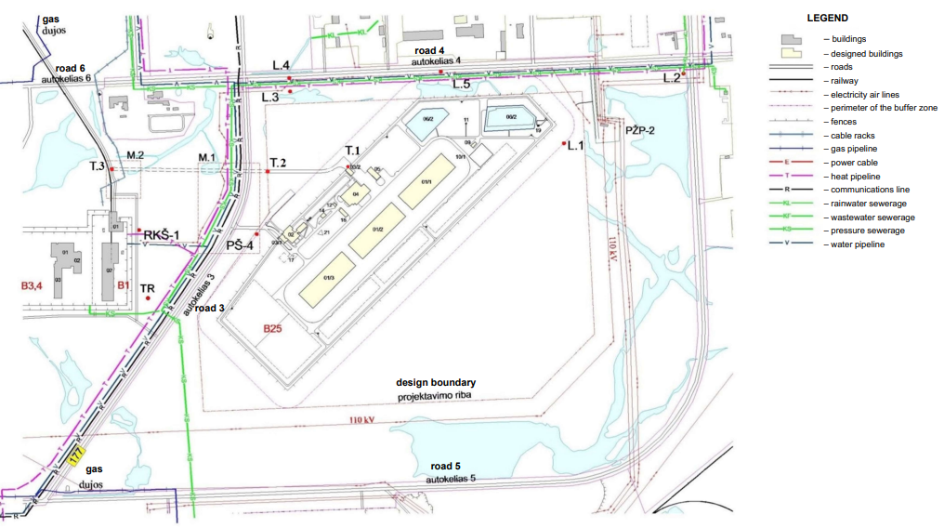
LEGEND OF B-25 BUILDINGS:
01/1; 01/2; 01/3 – Radioactive waste vaults
02 – Administrative building
03/1; 03/2 – Control posts
04 – Technological building
05 – Auxiliary building
06 – Rainwater and drainage water reservoirs
09 – Rainwater and water treatment plants
11 – Meteorological station
12 – Modular transformer station and diesel power station
14 – Refueling platform
17 – Domestic wastewater pumping station
18 – Inert material storage facility
19 – Valve and sampling compartment

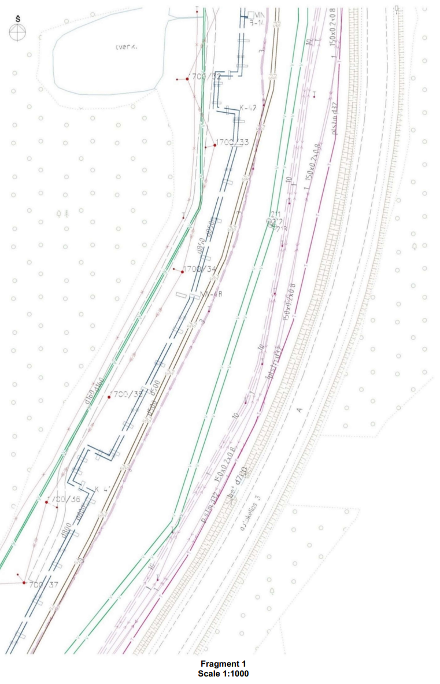

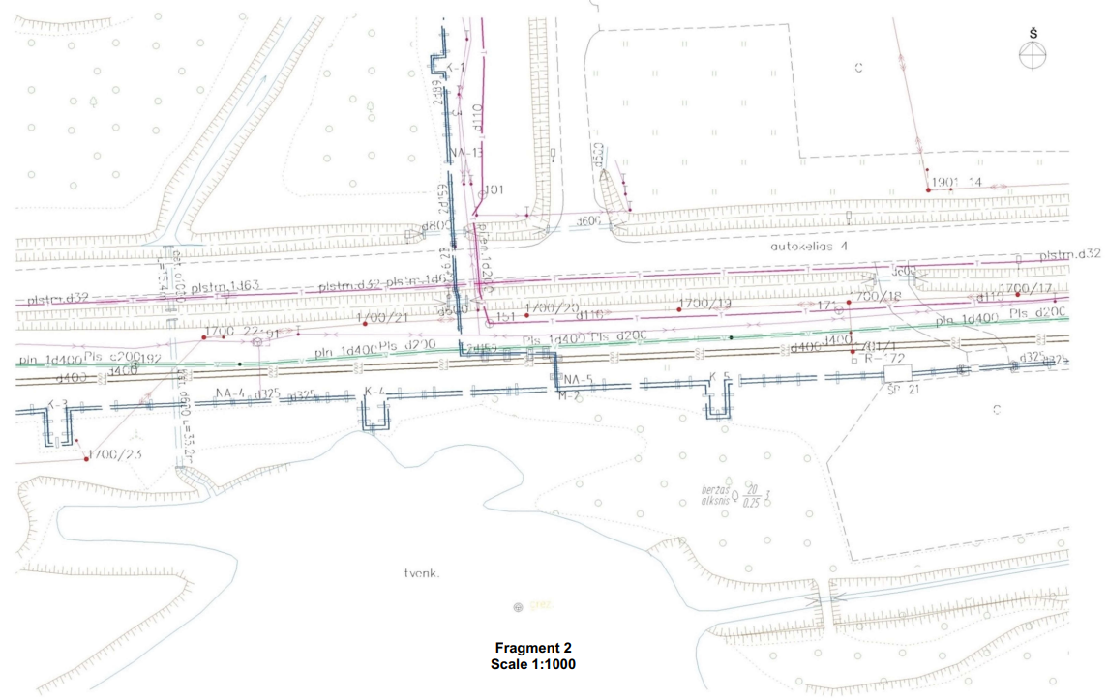

Technical Task for the Procurement of Works Related to the Construction of the INPP Near Surface Repository for Low- and Intermediate-Level Short-Lived Radioactive Waste (Construction Stages I/A, II/A) and Design, Construction and Connection of the External Rainwater Drainage Networks to the INPP Infrastructure
Annex 3 (5 pages)
LIST OF WORKS, SERVICES AND GOODS NOT INCLUDED IN THE SCOPE
OF THE PROCUREMENT
No. | Name of equipment/description of works | Unit of measure | Quantity
Administrative building 2 (construction stage I/A)
 | Computer desks 1800x900x750 mm | pcs | 26
 | Computer desks 1200x750x755 mm | pcs | 7
 | Conference table 3000x1300x755 mm | pcs | 2
 | Dining table 750x1200x760 mm | pcs | 4
 | Waiting room table | pcs | 2
 | Manager table with extensions | pcs | 1
 | Monitor table 4000x400x755 mm | pcs | 1
 | Table 750x1000x760 mm | pcs | 1
 | Reception administrator desk 2170x850x1145 mm | pcs | 1
 | Work chairs | pcs | 30
 | Visitor chairs | pcs | 32
 | Dining chairs | pcs | 16
 | Manager chairs | pcs | 2
 | Conference hall chairs | pcs | 39
 | Meeting room chairs | pcs | 9
 | Filing cabinets 1990x800x435 mm | pcs | 30
 | Filing cabinets 1990x800x435 mm | pcs | 8
 | Wardrobes 1990x800x435 mm | pcs | 9
 | Metal filing cabinet 1040x1000x400 mm | pcs | 10
 | Settees | pcs | 4
 | Medical examination bed 550x1852x500 mm | pcs | 1
 | Metal medicine cabinet | pcs | 1
 | Metal lockers 2210x600x490 mm placed on a bench | pcs | 18
 | Kitchen table with a sink 1200x600 mm | pcs | 1
 | Cupboard 800x320x720 mm | pcs | 1
 | Cloakroom barrier | pcs | 1
 | Cloakroom hangers | pcs | 6
 | Copier office equipment table | pcs | 4
 | Shelves for archives 1000x400x2000 mm | pcs | 6
 | Metal filing cabinets, with a lock | pcs | 2
 | Index cabinet | pcs | 1
 | Safety-deposit boxes | pcs | 3
 | Smart hall board | pcs | 1
 | Video display apparatus | pcs | 1
 | Switch cabinet with equipment | set | 1
 | Computer | set | 30
 | Printer | set | 11
 | Multifunctional device | pcs | 3
 | Installation of cabinet for apparatus and instruments 3000x800x850 mm | pcs | 1
 | Installation of drying cabinet | pcs | 2
 | Installation of technological table | pcs | 5
 | Installation of rack 3000x66x2000 mm | pcs | 1
 | Installation of technological table with a sink | pcs | 2
 | Installation of cabinet for laboratory equipment 1000x660x2660 mm | pcs | 1
 | Installation of rack 1800x700x2000 mm | pcs | 1
 | Installation of closed cabinet 1450x800xl900 mm | pcs | 1
 | Installation of laboratory fume cupboard assembly | pcs | 1
 | Installation of desk | pcs | 2
 | Installation of cabinet for apparatus and instruments 1000x600x2000 mm | pcs | 1
 | Installation of table with a ceramic sink | pcs | 1
 | Cabinet for apparatus and instruments 3000x800x850 mm | pcs | 1
 | Drying cabinet maximum constant temperature 300°C, 552x540x700 mm N-3.2 kW | pcs | 2
 | Technological stainless-steel table 1000x1200x850 mm | pcs | 5
 | Prefabricated metal rack 3000x600x2000 mm, rack load 100 kg | pcs | 1
 | Technological table with a stainless-steel sink 1000x700x850 mm | pcs | 2
 | Cabinet for laboratory apparatus, vessels 1000x600x2000 mm | pcs | 1
 | Prefabricated metal rack 1800x700x2000 mm | pcs | 1
 | Closed cabinet for work with enhanced level radioactivity substances 1450x800x1900 mm | pcs | 1
 | Laboratory fume cupboard assembly 1.6x0.8x2.4 m L-375 m³/h | pcs | 1
 | Gamma spectrometric complex 212.1x132.3x79 cm | pcs | 1
 | Desk 2000x600x850 mm | pcs | 2
 | Cabinet for apparatus and instruments 1000x660x2000 mm | pcs | 1
 | Dosimeter cartridge holder | pcs | 1
 | Domestic refrigerator, capacity 310 l, N-0.15 kW | pcs | 1
 | Microwave oven N-1.5 kW | pcs | 1
 | Kitchen table with a ceramic sink | pcs | 1
 | Telephones | pcs | 30
Administrative building 4 (construction stage I/A)
 | Computer desks 1800x900x750 mm | pcs | 14
 | Metal two compartment lockers 1850x350x500 mm | pcs | 71
 | Metal boxes for clothing 500x700 mm, stainless steel | pcs | 12
 | Metal frame benches coated with enamel paint 400xl000x330 mm, top covered with laminate | pcs | 28
 | Metal cabinets with shelves for clean clothing 700x450x1500 mm, with powder coating | pcs | 10
 | Metal boxes for shoes | pcs | 2
 | Computer tables 1800x750x755 mm with durable decontaminable finishing surface, coated with plastic laminate | pcs | 6
 | Desk 1400x750x755 mm with drawers, laminated | pcs | 1
 | Monitor table 2000x400x755 mm | pcs | 2
 | Adjustable work chairs with armrests and headrests, coated with imitation leather | pcs | 14
 | Metal work chairs with armrests, coated with plastic laminate (decontaminable) | pcs | 6
 | Metal filing cabinets 1200x1000x400 mm with shelves, doors | pcs | 8
 | Metal filing cabinet 1800x1000x400 mm | pcs | 6
 | Resting room tables 800x1400x755 mm | pcs | 4
 | Resting room chairs with armrests and headrests, coated with imitation leather | pcs | 14
 | Telephone | pcs | 20
 | Hydraulic barrel lifter, lifting capacity 1000 kg, lifting height 1510 mm, fork length 1122 mm, fork width 60 mm | pcs | 1
 | Plug transportation vehicle with a lifter, lifter capacity min. 700 kg | pcs | 1
 | Plug transportation carriage, lifting capacity 2200 kg, fork length 1150 mm, fork width 160 mm | pcs | 1
 | F-ANP container temporary plugs | pcs | 60
 | KTZ container temporary plugs | pcs | 60
 | Telephone cabinet | pcs | 1
 | Computer | pcs | 11
 | Printer | pcs | 4
 | Multifunction device | pcs | 2
Auxiliary building 5 (I/A construction stage)
 | Telephone | pcs | 1
 | Installation of racks | pcs | 10
 | Installation of locksmith workbench | pcs | 2
 | Installation of bench drilling machine | pcs | 1
 | Installation of two-disc grinding machine ø200 mm | pcs | 1
 | Installation of dust collector 900 m³/h | pcs | 1
 | High pressure washing pump with electrical heating 6.4 kW 450–900 l/h | pcs | 1
 | Modular racks for parts, assemblies, six shelves, shelve load 0.2 t, compartment 1.0x0.4x2.0 m | pcs | 10
 | Locksmith workbench with reinforced top, racks 2000x700x920 mm | pcs | 2
 | Bench drilling machine, power capacity N-0,6kW, 3F | pcs | 1
 | Two-disc grinding machine, disc ø200 mm, N-2,5kW, package with dust collector 900 m³/h, N-2.2kW | pcs | 1
 | Metal waste container, capacity 1.0 m³, closed, stationary | pcs | 1
 | Locksmith press, width of the tongs 125 mm | pcs | 4
 | Mobile ladder with platform, 14 ladders, reachable height 5.28 m, height of the platform 3.28 m | pcs | 1
 | Frontal lift, mobile, lifting height 4.6 m, scoop volume ~0.5 m³, lifting weight 2000 kg at the bottom and 1400 kg at the top | pcs | 1
 | Industrial sweeping, snow cleaning machine, capacity 10000 m³/h | pcs | 1
 | Mower, self-propelled, with two-stroke spark engine, capacity 3000 m²/h | pcs | 1
 | ABC type powder fire extinguisher, 6 kg capacity | pcs | 3
Control post 31 (I/A construction stage)
 | ABC type powder fire extinguisher, 6 kg capacity | pcs | 1
Control post 32 (I/A construction stage)
 | ABC type powder fire extinguisher, 6 kg capacity | pcs | 1
Site layout 1001 (I/A construction stage)
 | Bollard benches | pcs | 7
 | Waste bins | pcs | 7
 | Domestic waste containers | pcs | 3
Other construction works and equipment
 | Meteorological station equipment and its installation | pcs | 1
 | Technological road from T.1 to T.3 (see Annex 9) | m | –
 | Refuelling platform (building 14) and related infrastructure | – | –
 | Container transportation vehicles | pcs | 3
 | Container transportation vehicle trailers | pcs | 3
 | FANP type containers | pcs
 | KTZ type containers | pcs
 | Repository boiler house | pcs | 1
B25 Project Manager Signed by the unqualified electronic signature Jurgis Gelčys

Technical Task for the Procurement of Works Related to the Construction of the INPP Near Surface Repository for Low- and Intermediate-Level Short-Lived Radioactive Waste (Construction Stages I/A, II/A) and Design, Construction and Connection of the External Rainwater Drainage Networks to the INPP Infrastructure
Annex 4
EXTERNAL RAINWATER DRAINAGE NETWORK INSTALLATION SCHEME
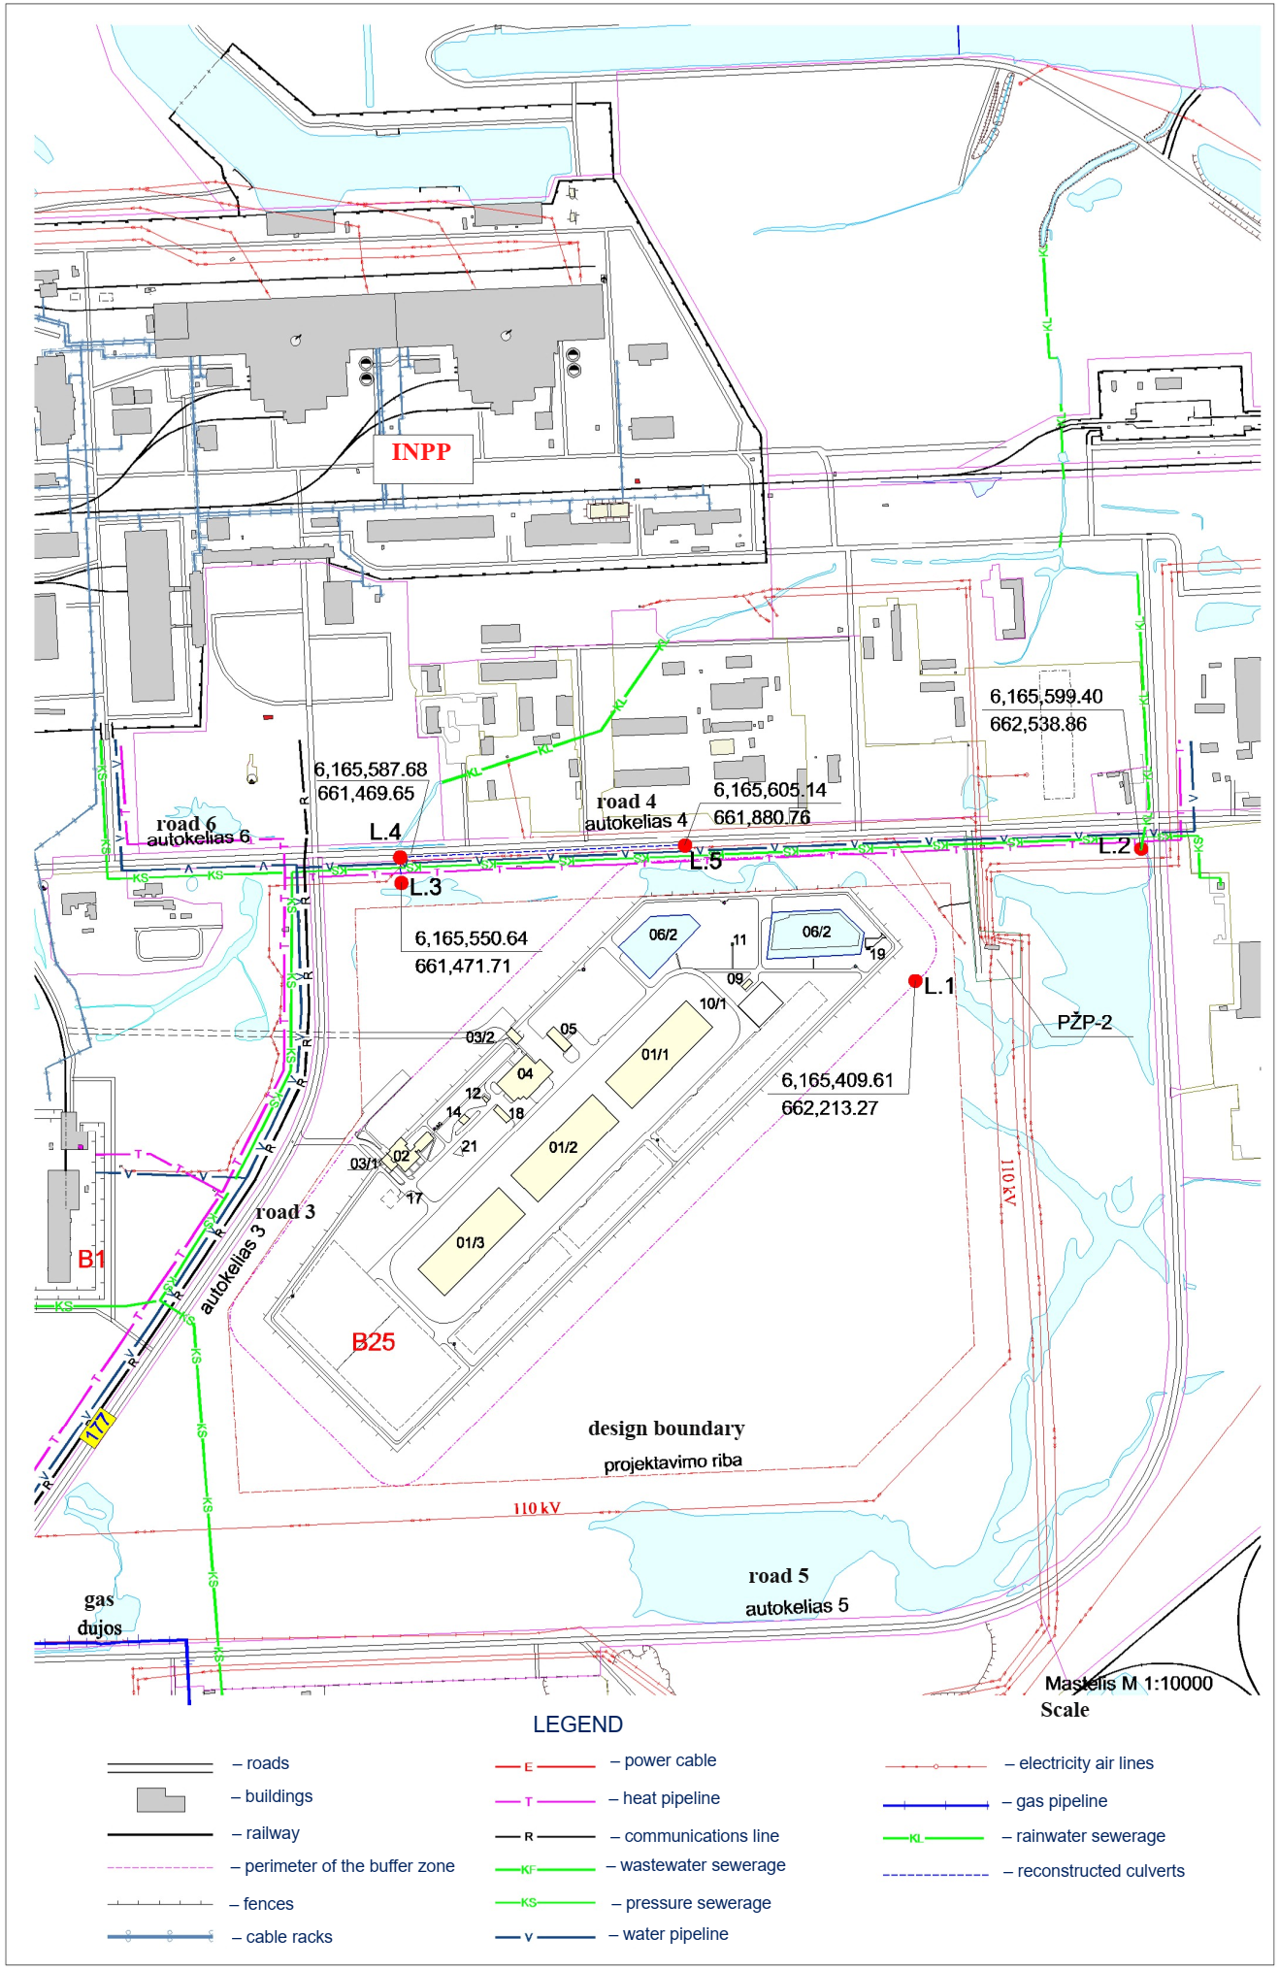
Technical Task for the Procurement of Works Related to the Construction of the INPP Near Surface Repository for Low- and Intermediate-Level Short-Lived Radioactive Waste (Construction Stages I/A, II/A) and Design, Construction and Connection of the External Rainwater Drainage Networks to the INPP Infrastructure
Annex 5
REQUIREMENTS FOR THE EXTERNAL RAINWATER DRAINAGE NETWORKS OF THE REPOSITORY AND THEIR CONNECTION TO THE INPP INFRASTRUCTURE
In order to ensure water drainage from point L.1 (well No.1 designed in Melioration part, coordinates X=6165409.61, Y=662213.27) to point L.2 (coordinates X=6,165,599.40 and Y=662,538.86), a water removal system shall be designed and installed, using the existing water bodies as much as possible (see Annex 4), pipe bottom (duct) mark 146.15.
In order to ensure the lowering of the surface water level on the Repository site, deepening of INPP’s existing rainwater drainage pipe (between points L.3–L.4) shall be designed and implemented in the rainwater drainage design, replacing the existing reinforced concrete pipe with a plastic pipe, as well as cleaning and deepening of the existing water ditch along road No. 4 at the necessary section which must not be shorter than the one between axes L.4 and L.5 (see Annex 4).
Technical Support Division Head Signed by the unqualified electronic signature Kęstutis Taparavičius
Technical Task for the Procurement of Works Related to the Construction of the INPP Near Surface Repository for Low- and Intermediate-Level Short-Lived Radioactive Waste (Construction Stages I/A, II/A) and Design, Construction and Connection of the External Rainwater Drainage Networks to the INPP Infrastructure
Annex 6 (3 pages)
REQUIREMENTS FOR THE EXTERNAL RAINWATER DRAINAGE NETWORKS OF THE REPOSITORY
2022-09-02, ĮG-3857
POWER NETWORKS AND EQUIPMENT TRANSFER (RECONSTRUCTION) CONDITIONS, No. ISK22-91566 | Prepared on 26 August 2022,
 | Valid till 26 August 2023
Client: SE Ignalina NPP
Contact details of the Client: Drūkšiniai village, Visaginas municipality, +370 386 28985, iae@iae.lt
Name of the Object: Near Surface Repository for Low- and Intermediate-Level Short-Lived Radioactive Waste
Address of the Object: Drūkšiniai village, Visaginas mun.
Investment project No.: E2N7291566
- Power Networks and Equipment Transfer (Reconstruction) Conditions were issued in response to the application No. 22-91566 submitted by the Client regarding the transfer/reconstruction of the power networks and equipment of AB Energijos skirstymo operatorius (hereinafter – the Company).
- The limit of the property and assets operations shall be determined –
- The Client’s actions in implementation the conditions:
  - To acquire a design for the transfer/reconstruction/protection of the engineering networks and/or electrical equipment which belongs to the Company (choose an independent design company with the necessary qualifications) in accordance with the technical solutions of these connection conditions.
  - After the design (digital version) has been prepared and the „Engineering Networks Design Contract“ according to https://www.eso.lt/lt/eso-partneriams/projektuotojams_2205/elektros-dalis/inzineriniu-tinklu-projektavimo-sutartis.html has been signed, both to be provided as the supporting documents via https://www.eso.lt/lt/eso-partneriams/elektros-partneriams/dokumentu-pateikimas.html.
  - To get acquainted with the Contract for the Service of Transfer (Reconstruction) of the Engineering Networks and/or Electrical Equipment owned by the Company and pay the service fee. To make a payment by logging in to the Company self-service website at www.eso.lI/savitarna, section „Paraiškos“.
  - Important information:
When reconstructing or transferring 0.4–10 kV air power lines and/or air cable lines owned by the Company that were installed more than 20 years ago, except for transformer substations, transformer stations, distribution points, obstructing the buildings’ construction or for other reasons, you will pay 50% of the costs incurred by the Company in reconstructing or transferring the mentioned power networks. For other reconstructed or transferred power networks and/or installations, the connection fee shall be equal to the actual cost of the materials and other costs consumed by the successful contractor and the Company that are directly related to the implementation of these conditions for connection (i. e., you will pay 100% to the Company). The ownership of reconstructed or transferred distribution networks shall not be altered.
According to the design you have prepared and agreed with the Company, you have the possibility to choose an independent contractor who will organize and perform the work on installation of the power distribution network. For more information see www.eso.lt/lt/namams/elektra/paslaugos_fast-track-modelis.
Client service  Client service tel. 1852 or 8 697 61 852*  Free power failure line 1852  Free gas disruption line 1804  Website: www.eso.lt  *Long number is charged according to customer’s communication operator plan rates | Company details  AB Energijos skirstymo operatorius  Laisvės pr. 10, LT 04215 Vilnius, Lietuva (Lithuania)  E-mail. info@eso.lt  Legal entity code 304151376  VAT code: LT 100009860612  Registry manager SE Registrų centras  E. delivery 304151376
The Company processes your personal data only on the legitimate grounds defined in legal acts. More detailed information on the conditions of processing of your personal data and related rights is publicly available on the Company’s website www.eso.lt

  - Technical requirements for the design part of the power network:
    - To design the rearrangement, transferring, reconstruction, protection, dismantling and/or removal of engineering, telecommunication networks, electrical equipment owned by the Company, which obstruct works on construction or reconstruction. The design shall provide for the return of accounting devices that are to be moved and owned by the Company.
    - To take into account when designing the rearrangements of networks and/or equipment, that after the implementation of works the power supply to existing customers would be resumed.
    - The 0.4–10 kV air power lines and air cable lines installed more than 20 years ago are distinguished by a separate estimate. You can check the age of air power lines and air cable lines at
https://www.eso.lt/lt/verslui/elektra_99/paslauqos-ir-elektros-prietaisu-remontas/elektros-oro-ir-oro-kabeliu-liniju-amzius.html
- Actions taken by AB Energijos skirstymo operatorius in the implementation of the Object connection:
  - The Company will carry out the contract works in accordance with the design prepared and agreed by the Client.
- Other information
  - You can view the power connection process on the self-service website of AB Energijos skirstymo operatorius at www.eso.lt.
More actual information on the next steps in the connection of power equipment and other services provided by AB Energijos skirstymo operatorius can be found at www.eso.lt or, if you have any additional questions, you can be assisted by your personal manager, whose contact details can be found by logging in to your account on the self-service website, which can be found at www.eso.lt.
Calls are charged according to the applicable rate or payment plan of your chosen communication operator.
Client service  Client service tel. 1852 or 8 697 61 852*  Free power failure line 1852  Free gas disruption line 1804  Website: www.eso.lt  *Long number is charged according to customer’s communication operator plan rates | Company details  AB Energijos skirstymo operatorius  Laisvės pr. 10, LT 04215 Vilnius, Lietuva (Lithuania)  E-mail. info@eso.lt  Legal entity code 304151376  VAT code: LT 100009860612  Registry manager SE Registrų centras  E. delivery 304151376
The Company processes your personal data only on the legitimate grounds defined in legal acts. More detailed information on the conditions of processing of your personal data and related rights is publicly available on the Company’s website www.eso.lt

2022-09-02, ĮG-3853

The original will not be sent
SE Ignalina Nuclear Power Plant 2022-08-31 No.
To 2022-08-17 No. IS-3895(15.59.1E)
CONCERNING THE PROVIDING OF THE CONNECTION CONDITIONS
Having considered the Letter of 17 August 2022 concerning the providing of technical conditions for the rainwater drainage of the Near surface repository for low- and intermediate-level short-lived radioactive waste, hereby we inform you that the operator of the power transmission system AB LITGRID (hereinafter – the Operator) has not issued the connection conditions to the high voltage power transmission lines (110 kV and higher voltage) owned and operated by the Operator.
Please provide diagrams from the technical design with the planned rainwater drainage networks for agreement with the Operator’s owned and operated high voltage power transmission lines (110 kV and higher voltage) networks.
Head of Eastern Region,
Infrastructure Maintenance Centre Rimas Savukas
Marius Urbonavičius, tel. 8 618 67605, marius.urbonavicius@litgrid.eu

AB LITGRID  Karlo Gustavo Emilio Manerheimo g. 8  LT-05131 Vilnius | +370 707 02171  info@litgrid.eu  www.litgrid.eu | Company code: 302564383  VAT payer code: LT100005748413

Technical Task for the Procurement of Works Related to the Construction of the INPP Near Surface Repository for Low- and Intermediate-Level Short-Lived Radioactive Waste (Construction Stages I/A, II/A) and Design, Construction and Connection of the External Rainwater Drainage Networks to the INPP Infrastructure
Annex 7
REQUIREMENTS FOR THE SUPPLIED MEASURING INSTRUMENTS
The Contractor shall ensure that the following measuring instruments within the scope of legal metrological regulation shall be provided:
- which are included in the Lithuanian State Register of Measuring Instruments, except for simple measuring instruments which, according to the Rules on Legal Metrological Regulation of Measuring Instruments, are not subject to the type assessment and approval;
- which have marks and/or seals and issued verification certificates established in legislation. The metrological verification must be valid for at least until the end of the II/A construction completion procedures.
The measuring instruments outside the scope of legal metrological regulation and technological control measuring instruments (installed in the technological equipment according to the design and intended for measuring of technological processes) must be provided with the documents evidencing conformity of the measuring device with the requirements of the technical specification of the manufacturer, e.g. calibration certificates, verification certificates, control certificates or other equivalent documents.
The technological control measuring instruments designed for measuring packaging must be provided with the methodologies for measuring packages and for verifying and/or calibrating said measuring instruments, prepared by manufacturers of this equipment. Verification and/or calibration must be carried out after final installation of the equipment in the Repository and upon provision of the verification and/or calibration certificates (the documents must also be valid also during ‘hot’ trials) and agreed methodologies till the commencement of the II/A construction completion procedures.
Verification and Calibration
Laboratory Head Signed by the unqualified electronic signature Jurijus Katvickis

Technical Task for the Procurement of Works Related to the Construction of the INPP Near Surface Repository for Low- and Intermediate-Level Short-Lived Radioactive Waste (Construction Stages I/A, II/A) and Design, Construction and Connection of the External Rainwater Drainage Networks to the INPP Infrastructure
Annex 8
Technical Design OptimiZation Solutions
The Contractor must examine the TD and, if it is rational and does not contradict the requirements and solutions set out in the TT and Repository TD, shall submit the proposals for the optimization of the Repository TD solutions. Such Contractor’s proposals shall not: (1) reduce the safety of the Repository, (2) increase the risks for Employer during construction, testing, operation and decommissioning of the Repository, (3) change any essential structure design solutions set out in the Repository TD, which could result in repeated expertise of the TD and/or agreement with the Authorities. In any case the Contractor’s proposed design solutions, equipment and materials must be in line with other Repository TD solutions, comply with the requirements of normative legal acts and ensure the safety of the Repository during its operation, supervision and decommissioning.
The following Repository TD optimization solutions may be offered:
- Replacement of copper cables with other cables (except for the administrative building);
- Replacement of aluminium windows with other windows (except for the administrative building);
- Internal finishing of the buildings (except for the administrative building);
- External finishing of the buildings and insulation with cheaper alternative materials (except for the administrative building);
- Replacement of sodium, fluorescent, halogen, metal halogen, compact fluorescent lamps with LED lamps which ensure the same or better lighting level.
- Replacement of installation cables with PVC external insulation with non-halogen cables.

Technical Task for the Procurement of Works Related to the Construction of the INPP Near Surface Repository for Low- and Intermediate-Level Short-Lived Radioactive Waste (Construction Stages I/A, II/A) and Design, Construction and Connection of the External Rainwater Drainage Networks to the INPP Infrastructure
Annex 9
TECHNOLOGICAL ROAD LAYOUT SCHEME
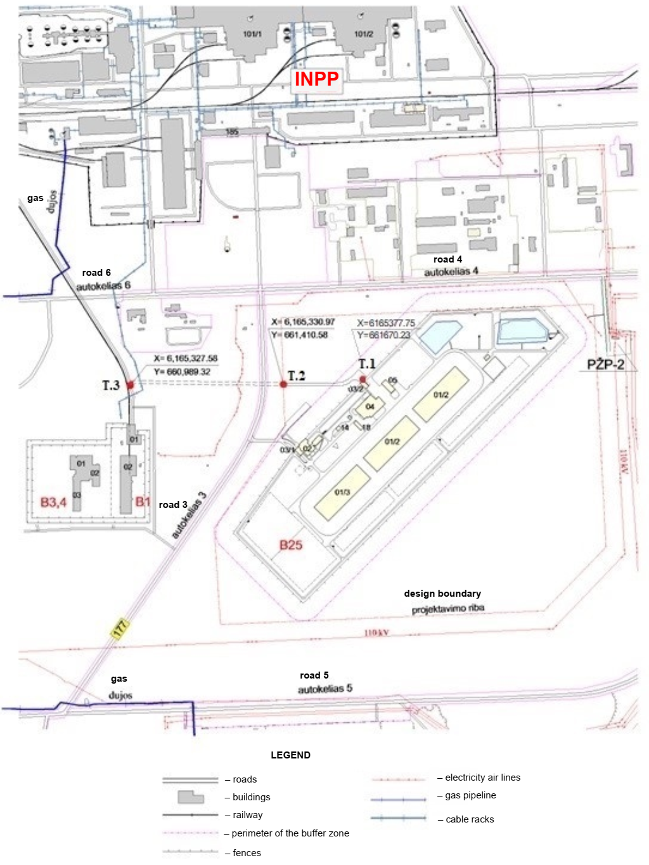

Technical Task for the Procurement of Works Related to the Construction of the INPP Near Surface Repository for Low- and Intermediate-Level Short-Lived Radioactive Waste (Construction Stages I/A, II/A) and Design, Construction and Connection of the External Rainwater Drainage Networks to the INPP Infrastructure
Annex 10
LEGEND OF THE PREMISES OF BUILDING 02
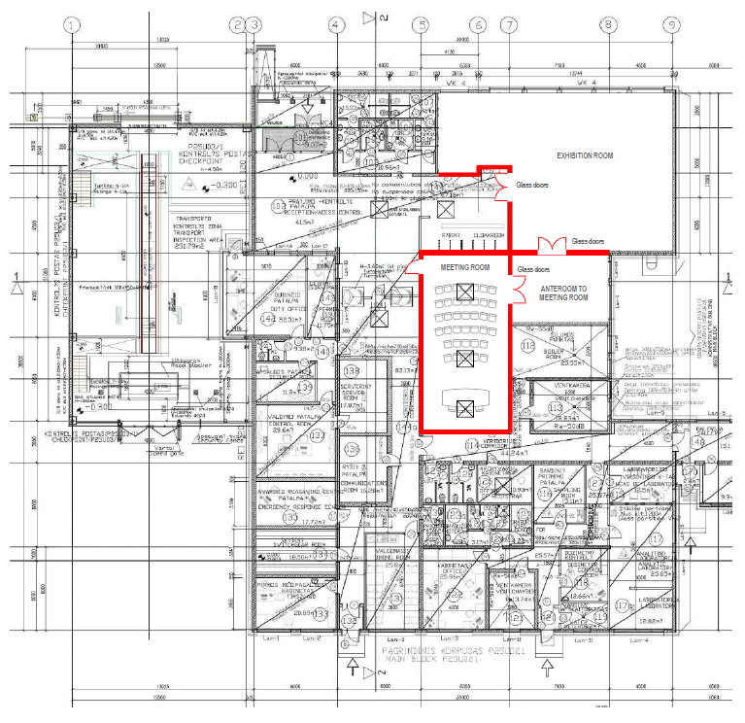

Technical Task for the Procurement of Works Related to the Construction of the INPP Near Surface Repository for Low- and Intermediate-Level Short-Lived Radioactive Waste (Construction Stages I/A, II/A) and Design, Construction and Connection of the External Rainwater Drainage Networks to the INPP Infrastructure
Annex 11
scope of the ‘cold’ and ‘hot’ trial programmes
The content of programmes for the individual trial of the equipment, systems, and components of the repository in each specific case shall be agreed with FIDIC engineer in accordance with the factory documentation, TD, EDD, normative legal acts.
The description of the ‘cold’ and ‘hot’ trial programmes must include trial procedures, the critical path, acceptability criteria and allowable deviations, also ways of solving non-standard situations that arise during the trials.
During the performance of ‘cold’ trials, which will be the responsibility of the Contractor, operation of all the equipment, systems, and components of the Repository, including external infrastructure, as installed during stages I/A and II/A must be demonstrated under the supervision of INPP’s specialists. During the ‘cold’ trials, a full cycle of operations with 4 containers (2 KTZ-3.6 and 2 F-ANP which will be filled with imitators (non-radioactive materials – metal waste KTZ-3.6 containers (approx. 1.8 t for each container), and 16 pcs (8 pcs to each F-ANP container) 200 l drums filled with cement no less than 93% and no more than 95% by volume))) must be performed according to the programme, demonstrating their transportation from the place of generation to the technological building of the near surface repository, their cementing in the technological building and placement into the 1st- and 2nd-group vaults (initially placing all 4 containers in the vault of 1st group and later in the vault of 2nd group), as well as demonstrating other operations as envisaged in the programme.
During the ‘cold’ trials the Contractor must demonstrate the operation of the vault grouting facility designed in accordance with the TT p.10.8.9 and delivered and installed by the Contractor; i.e., the level of one vault floor must be levelled (eliminating the slope of the entire one vault floor area without changing the design floor highest altitude) imitating grouting of the spaces between containers.
During the performance of I stage ‘hot’ trials, which will be the responsibility of the Employer, operation of all the equipment, systems, and components of the Repository, including external infrastructure, as installed during stage I/A must be demonstrated under the supervision of Contractor’s specialists. During the I stage ‘hot’ trials, a full cycle of operations with 112 F-ANP containers filled with radioactive waste must be performed according to the programme, demonstrating transportation of these containers from the place of generation to the technological building of the near surface repository, their cementing in the technological building and placement in one of the vaults of the 1st group without pouring concrete, as well as demonstrating other operations as envisaged in the programme.
The ‘cold’ and ‘hot’ trial programmes and reports will have to be agreed with VATESI, i.e., the INPP, upon receiving and agreeing on the Contractor’s ‘cold’ and ‘hot’ trial programmes and reports, will prepare on their basis ‘cold’ and ‘hot’ trial programmes and reports that will be agreed with VATESI. The Contractor must, if necessary, be involved into agreement of ‘cold’ and ‘hot’ trial programmes, and must make necessary amendments to the programmes and reports prepared by the Contractor.

SCOPE OF THE TRIAL PROGRAMMES:
The goal of the trials.
Definitions and abbreviations.
Liability.
References.
Initial status.
The trial execution procedure (preparation and the initial status of adjacent systems, technological limitations, work performance procedure, required devices and materials, etc.).
Limitations.
Safety measures.
Measures to ensure radiation safety.
Criteria of successful trials.
Programme implementation results.
Actions of the personnel in case of emergency situations.
Technical Task for the Procurement of Works Related to the Construction of the INPP Near Surface Repository for Low- and Intermediate-Level Short-Lived Radioactive Waste (Construction Stages I/A, II/A) and Design, Construction and Connection of the External Rainwater Drainage Networks to the INPP Infrastructure
Annex 12
Requirements for preparation of structures’ subsidence monitoring programme
- The Programme shall be prepared in accordance with the Design documentation of the Repository, the requirements of the normative legal acts specified by TT.
- During preparation of the Programme the Contractor must take into account comments, suggestions of FIDIC engineer and Repository Designer.
- The Programme will be considered properly prepared:
  - Upon agreement of the Programme by the Contractor with FIDIC engineer, and after making the adjustments in accordance with the comments and suggestions submitted by FIDIC engineer and Repository Designer;
  - When the Contractor receives approval letters for this Programme from FIDIC engineer and Repository Designer. FIDIC engineer will provide the Contractor with a copy of the Repository Designer’s approval letter.
  - When the Contractor submits a full-scale Programme to the INPP and FIDIC engineer. The Programme must be signed by all responsible persons of the Contractor, INPP and FIDIC engineer.
  - The Contractor, upon receipt of FIDIC engineer’s instruction or at other circumstances requiring corrections of the Programme, must adjust it in full or correct separate parts (depending on the FIDIC engineer’s instruction or other circumstances) and provide these amendments for agreement to FIDIC engineer and Repository Designer, taking into account the comments and suggestions submitted by the INPP, FIDIC engineer and Repository Designer during agreement of the updated Programme.
- The Contractor must make corrections of the Programme within the timeframe specified by FIDIC engineer. However, the term for corrections of the Programme, even in the event of unforeseen circumstances, cannot exceed 10% of the term set for submission of the appropriate Programme to FIDIC engineer in the Contractor’s Work Schedule, which was agreed by FIDIC engineer upon the entry into force of the Repository Construction Contract.
- Minimum content of the Subsidence Monitoring Programme: Purpose and scope; Responsibilities of the INPP, FIDIC engineer and Contractor; Detailed subsidence control procedure and detailed methods; Requirements for submission of reports (frequency), limit and actual subsidence; Content of the Report; Annexes (reports such as geodetic mark schemes).

Technical Task for the Procurement of Works Related to the Construction of the INPP Near Surface Repository for Low- and Intermediate-Level Short-Lived Radioactive Waste (Construction Stages I/A, II/A) and Design, Construction and Connection of the External Rainwater Drainage Networks to the INPP Infrastructure
Annex 13 (6 pages)
CLARIFICATION AND EXPLANATION OF THE REQUIREMENTS OF THE TECHNICAL DESIGN
- It is clarified that a fully updated Technical Specification of the Integrated Radiation Monitoring System (see PD Annex 14) provided in the Technical Design Radiation Safety part must be applied for the design and installation of the NSR IRMS. In case of inconsistencies or contradictions in the design documentation regarding the updated content of NSR IRMS Technical Specification, precedence must be given to the updated Technical Specification of the NSR Integrated Radiation Monitoring System provided in the Radiation Safety design part.
- The cost estimates in the Technical Design (CE part) are provided for information purposes only and do not include all the potential costs to be incurred by the Contractor in relation to the subject of the purchase.
- It is clarified that the safety classification marking of the systems and components with symbol “H” (e.g., safety class 3H) must be read as “N” in the text of the Technical Design according to the classification marking indicated in point 27 of section 6.2.1 in No. B25-1/S/14-1129.9.12/PSAR-DR/R:3 of the Preliminary Safety Analysis Report “B25-1 Project – Near Surface Repository for Low- and Intermediate-Level Short-Lived Radioactive Waste (Design)”.
- The following turnstile (p. 8.5 in the List of Materials and Products of the Technical Design Architectural Part (SM1301P25-02-TP-SA_MZ-1A)) requirements are defined: Placement locations must be envisaged from both sides of the turnstile for installation of badge readers. Turnstile external dimensions: 1520 mm±3% x 2100 mm±3%; height – 2375 mm±3%; operating temperature from +5ºC to +40ºC, however, a wider range of operating temperatures may be offered. Mains supply rated voltage: 230 V, rated frequency: 50 Hz. The turnstile must have CE marking and comply with the requirements of ISO 1600 standard or equivalent and ingress protection class at least IP20, electronic.
- Position 10 of the List of Equipment of the Technical Design Technological Part (SM1301P25-04-TP-TG_IZ-1B) is clarified as follows: ID – P25KPH10AX05; Unit – pcs;
quantity – 1.
- The following is explained:
  - All the cranes envisaged in the TD for the operations with containers filled with radioactive waste to be designed, supplied, and installed in accordance with the requirements set out in the procurement documents must: (1) have protection against single failure, (2) have protection to ensure safe load lowering in emergency situations, (3) be fully equipped and have all the equipment, systems, components intended for proper operation. These cranes must also comply with all other requirements for this type of cranes set out in the procurement documents and relevant regulatory documents. If the Contractor is unable to implement the solutions established in the TD or if the Contractor considers that these solutions are not sufficient other solutions must be proposed in accordance with the requirements of clause 51 of this TT. These solutions must be included in the tender price;
  - the operating temperature range of the cranes in the technological building (P25KPH10AE01 and P25KPH10AE02) and container handling trolley (P25KPH10AE 03,04,05,06) must be at least from +5° C to +40° C;
  - the dose rate of the container to be handled with cranes will reach ≤ 10 mSv/h at the distance of 0.1 m;
  - Crane positioning +/- 10 mm must only be applied to cranes that are operated with containers filled with radioactive waste (P25KPH30AE01, P25KPH30AE02, P25KPH10AE01, P25KPH10AE02). Other cranes are not subject to these requirements.
- Requirements for the equipment provided in the List of Equipment of the Technical Design Technological Part (SM1301P25-02-TP-TG_IZ-1B) are clarified as follows: Metal detector (P25DYZ00AW01/02, 2 pcs), luggage control X-ray machine (P25DYZ00AW03, 1 pc), mobile equipment for detection of explosives (P25DYZ00AW04, 1 pc), installed equipment for detection of explosives (P25DYZ00AW05, 1 pc). The physical protection equipment specified in the Technical Design must comply with the following below listed requirements:
  - Installed metal detector (P25DYZ00AW01/02, 2 pcs).
Detector type: installed. Installed metal detector is used to control the entry and exit of persons to detect the presence of different size (including very small) metal and/or metal alloy items, weapons or other items which could be harmful to people or protected objects, as well as mobile communications or electronic devices. Visual (optical) or audible alarm will be activated if prohibited items and/or devices detected. The internal dimensions of a passage at least: width 700 mm, height 2000 mm. External dimensions not more than: width 950 mm, height 2400 mm. Operating ambient temperature from +5º C to +40º C. However, a wider range of ambient temperatures may be offered. The following parameters must be set up as a minimum: zoning, sensitivity. 3 zoning triggering positions must be as a minimum. Sensitivity range must be adjustable. Mains supply rated voltage: 230 V, rated frequency: 50 Hz. Must have CE marking and comply with the requirements of ISO 1600 standard or equivalent and ingress protection class at least IP20. The possibility to disable wireless remote control (if any) must be envisaged. The control must ensure the possibility to program all functions only by using access codes. The access codes must be provided together with the software, enabling the Customer to change the settings of the supplied physical security equipment without any restriction.
  - Luggage control X-ray machine (P25DYZ00AW03, 1 pc)
Luggage control X-ray machine is used to detect the presence of dangerous and prohibited items (see the list in the document No. DVSta-2108-6 dated 2019-03-07 “SE INPP Description of Procedures for Ensuring Physical Security of the Nuclear Energy Objects” (in Lithuanian), Annex 3, (enclosed)) in a hand luggage. Passage dimensions: height – at least 410 mm, width – at least 620 mm, transport lane length – at least 1700 mm, weight of the checked luggage on the transport lane – up to 160 kg, display resolution – at least 1280x1024 pixels, 24-bit colour depth. Operating ambient temperature from +5º C to +40º C. However, a wider range of operating temperatures may be offered. Mains supply rated voltage: 230 V, rated frequency: 50 Hz. Must have CE marking and comply with the requirements of ISO 1600 standard or equivalent and ingress protection class at least IP20 for apparatus and at least IP43 for keyboard. Anode voltage must be from 140 kV to 160 kV.
  - Mobile equipment for detection of explosives (P25DYZ00AW04, 1 pc).
Mobile equipment for detection of explosives is used to check entering personnel, freight and vehicles. The following explosives to be detected as a minimum: Trotyl (TNT), Nitroglycerin (NG), Pentrit (PETN), Hexogen (RDX). Equipment must not contain sources of ionizing radiation. ambient temperature from -10º C to +40º C. However, a wider range of operating temperatures may be offered. Must have CE marking and comply with ISO 1600 standard requirements and ingress protection class at least IP54.
Operating time of an autonomous power source must be at least 4 hours. The kit must include a charging device for the autonomous power source as well as emergency power source with the same settings. Mains supply rated voltage: 230 V, rated frequency: 50 Hz. The set of consumables according to the list approved by the manufacturer of mobile explosives detection equipment (if applicable) taking into account a minimum of 20 daily checks, including at least 1 positive check.
  - Installed equipment for detection of explosives (P25DYZ00AW05, 1 pcs)
Installed equipment for detection of explosives s used to detect the presence of explosives and drugs for entering personnel. The following explosives to be detected as a minimum: Trotyl (TNT), Nitroglycerin (NG), Pentrit (PETN), Hexogen (RDX). Analysis rate – no longer than 14 sec. Integrated display. Case external dimensions: height – maximum 2.4 m, width – maximum 1.4 m, internal dimensions: height – at least 1.95 m, width – at least 0.7 m. Operating temperature from +5º C to +40º C. However, a wider range of operating temperatures may be offered. Mains supply rated voltage: 230 V, rated frequency: 50 Hz Must have CE marking and comply with the requirements of ISO 1600 standard or equivalent and ingress protection class at least IP20.
- The requirements for the equipment specified in the Lists of Equipment (SM1301P25-03_1-TP-TG_IZ-1A, SM1301P25-03_2-TP-TG_IZ-1A) of the Technical Design Production Technology Part: anti-ramming barriers (P25DYZ00AM04, 1 pc, P25DYZ00AM01, 1 pc, P25DYZ00AM02, 1 pc) and installed portal monitors for measurement of radiation background of road vehicles (P25RS00DR02, 1 pc, P25RS00DR01, 1 pc) are clarified as follows:
  - Anti-ramming barrier (P25DYZ00AM04, 1 pc, P25DYZ00AM01, 1 pc, P25DYZ00AM02, 1 pc)
The requirements presented in SM1301P25-03/1-TP-TG.IZ-1 document which are applied to anti-ramming barrier are supplemented as follows: The equipment shall be suitable for outdoor use. The equipment shall be compatible with all other Technical Design solutions. Remote control and possibility of manual closing and opening.
  - Installed portal monitor for measurement of radiation background of road vehicles (P25RS00DR02, 1 pc, P25RS00DR01, 1 pc).
Installed portal monitor for measurement of radiation background of road vehicles (radiation safety requirements are specified in SM1301P25-XX-TP-RS_TS-1). Two columns. Internal dimensions of the portal at least 4.0 x 4.5 m. Power supply, rated voltage: 230 V; rated frequency: 50 Hz, power no more than 0.5 kW.
- Concrete compressive strength specified in Section III Buildings No. 06/1 and No. 06/2 Storm Basins of the Technical Specification (SM1301P25-XX-TP-M_TS-1B) of the Technical Design Melioration Part is clarified: instead of “Slope reinforcement slabs shall be made of C25/30 compression strength class concrete with cold resistance of F200 and water impermeability W4” there should be “Slope reinforcement slabs shall be made of C30/37 compression strength class concrete with cold resistance of F200 and water impermeability W4”.

- The requirements for geotextiles stopping asphalt cracking used for installation of road pavement structure junction specified in item 14 (SM1301P25-00_1-TP-SAK_TSD-1B) of Works Technical Specification of the Technical Design Communication (Roads) Part are clarified as follows: nominal tensile strength ≥ 50 kN/m. Elongation at nominal tensile strength ≤ 3 %, raw material – fiberglass or equivalent, coating – bitumen.
- The requirements for drainage membrane under 4.1.7 in the List of Materials and Products of the Technical Design Structural Part (SM1301P25-02-TP-SK_MZ-1A): The drainage membrane used for foundation beams of the Administrative building is designed to protect the structures from mechanical damages and ground waters. Impermeability class of the membrane not less than W1, well width 8 mm (±0,8).
- There is additional requirement envisaged for the geotextile in section 12 of the Technical Specifications for Products, Jobs, Materials of the Technical Design Infrastructure Part (SM1301P25-00_1-TP-SAK_TSM-1B): longevity – not less than 100 years according to TRAGeosint ŽD 13 requirements.
- There is additional requirement envisaged for the geotextile in section 11 of the Technical Specifications for Materials and Products of the Technical Design Infrastructure Part (SM1301P25-00_2-TP-SAK_TSM-1B): longevity – not less than 100 years according to TRAGeosint ŽD 13 requirements.
- The subsection for Fence poles description in section 11 in the Technical Specification for Materials and Products of the Technical Design Site Plan part (SM1301P25-00_1-TP-SP_TSM-1A) is clarified by removing the requirement to the height of the bent armfence pole of 3600 mm.
- The requirements to disciplining fence under item 11 in the List of Works Quantities of the Technical Design Site Plan part (SM1301P25-00_1-TP-SP_DZ-1B) are complemented as follows:
Disciplining fence is required to prevent animals from approaching the main fence as well as to prevent false triggering of the alarm system installed on the main fence.
Installed around the entire perimeter and made of embedded in concrete reinforced concrete columns with barbed wire strips.
Fence height at least 1.5 m. Barbed wire spacing must be no wider than 0.15 m.
A decorative fencing of the same height is used for disciplining fence for the facade of the administrative building.
There are no intrusion requirements for disciplining fence elements.
- Height requirement to the fence segment indicated in section 1 Description of a Segment in Segmented Fencing in the Technical specifications for Materials and Products of the Technical Design Site Plan part (SM1301P25-00_2-TP-SP_TSM-1A) is clarified as follows: replace
1630 mm±3 mm with not less than 2500 mm.
- Section 8 Road Curbs, Lawn Curbs of Technical Specification for Materials and Products of the Technical Design Site Plan part (SM1301P25-00_1-TP-SP_TSM-1A) is clarified as follows:

  - Dimensions of Road Curbs: replace 100x30x18 with 100x30x15;
  - Dimensions of Entry Road Curbs: replace 100x22x18 with 100x22x15.
- The requirements of section 1.6 of the Explanatory Note of the Technical Design Site Plan part (SM1301P25-00_1-TP-SP_AR-1B) are clarified: replace concrete slab – 6 cm with concrete tiles – 6 cm.
- The lawn layer in section 6 Arrangement of Lawn of the Technical Requirements for Works of the Technical Design Site Plan part (SM1301P25-00_1-TP-SP_TSD-1A): instead of ~ 24 cm shall be no less than 15 cm.
- It is explained that in case when bitumen type requirements to the asphalt pavement are not provided in the Technical Specification for Materials and Products of the Technical Design Site Plan part (SM1301P25-00_1-TP-SP_TSM-1A), the bitumen type shall be chosen during the preparation of the Detailed Design following the Installation Rules of the Roads Pavement Asphalt Layers ĮT ASFALTAS 08 and Lithuanian standards (Technical Design Site Plan part Technical Specification for Materials and Products (SM1301P25-00_1-TP-SP_TSM-1A) section 2).
- Concrete compressive strength specified in section 6 as Concrete Pavement of the Technical Requirements for Materials and Products of the Technical Design Site Plan part (SM1301P25-00_1-TP-SP_TSM-1A) is clarified as follows: instead of “Concrete pavement is built using C40/50, W-6, F – 100 and made 30 cm thick” shall be “Concrete pavement is built using C30/37, W-6, F – 100 and made 30 cm thick”.
- It is clarified that installation works of the tables with signs “Prohibited area” provided in section 11 Disciplinary fence of the List of Works Quantities of the Technical Design Site Plan part (SM1301P25-00_1-TP-SP_DZ-1B) must be assessed.
- Section 10 Arrangement of Lawns requirements in the Technical Specifications of Materials and Products of the Technical Design Site Plan part (SM1301P25-00_1-TP-SP_TSM-1A) are clarified: replace “The diameter of tree seedlings is between 6 and 10 cm at 2-4 years depending on the type of sapling” with “The diameter of tree seedlings or small trees is between 6 and 10 cm depending on the type of sapling”.
- It is explained that structural drawings and lists of materials for different cover structures must be followed if any unclarity regarding the installation of geotextile layers specified in the Technical Design Site Plan part occurs.
- The ratio of levelling layer of concrete and sand provided in section 3 Sidewalk Pavements for Pedestrians in the Technical Requirements for Works of the Technical Design Site Plan part (SM1301P25-00_1-TP-SP_TSD-1A) is clarified: instead of 1:6 it shall be 1:3.
It is explained that general length of the Stakes for tree staking of h=2.0 m is indicated in item 9.6 of the List of Products, Goods and Materials of the Technical Design Site Plan part (SM1301P25-00_1-TP-SP_GZ-1B). Detailed information on the stake diameter and way of attaching shall be provided in the Detailed Design and durable stakes and excluding damage of trees must be foreseen.
- It is explained that flagpoles, which main features are provided in the Technical Specification of Materials and Products of the Technical Design Site Plan part (SM1301P25-00_1-TP-SP_TSM-1A) section 12, elements, including flagpole tops, shall be detailed in the Detailed Design.
- Power cable specification in drawing No. SM1301P25-12-TP-ET_B-1A of the Technical Design Electrotechnical Part shall be clarified as follows: replace 3×95Cu with 3×50Al, as specified under item 36 of the List of Materials (SM1301P25-12-TP-ET_MZ-1A) of the Technical Design Electrotechnical Part.
- All the cameras envisaged in the TD must be without access to external network, i.e., without the wireless communication module (WIFI, Bluetooth, GSM/GPRS or etc.).
- It is clarified that in the Asphalt Concrete Pavement Installation Chapter of the Quantity List of Works (SM1301P25-00_1-TP-SP_DZ-1B) of the Site Plan part of the Technical Design, it is necessary to assess the installation of a 15 cm layer of dolomite crushed stone mixture as specified in the Quantity List of Materials (SM1301P25-00_1-TP-SAK_DZ_1B_L) and in the drawing (SM1301P25-00_1-TP-SAK_B-6B).
- According to the solutions of the explanatory note of TD Site Plan part (SP-1 part) physical protection video surveillance system cameras are not in the scope of this procurement. Suppliers must assess installation of specified supports with foundations only, but without cameras. The Suppliers do not have to assess the insertion of cables into supports, but the structure of supports must allow cable insertion.
- In TD Site Plan part (SP-1 part), explanatory note is envisaged to metal wire rope anti-ramming system will be installed between perimeter fence and disciplinary fence. We hereby explain that within the scope of this procurement, a metal rope anti-ramming system must be installed. Therefore, the supplier must include in the tender price all costs related to the design and installation of this system. We also explain that the technical data and specifications of the system are provided in the List of Materials and Products SM1301P25-00/1-TP-SK.MŽ-1. Characteristics of other system components are given in SM1301P25-00_1-TP-SK_B-1A and SM1301P25-00_1-TP-SK_B-2A.
- Computer equipment for organizing (managing) technological processes must be purchased and installed by the Contractor. Computer equipment must be fully completed. The parameters of the computer equipment must ensure the reliable and safe (including cyber security) operation of the technological equipment supplied by the supplier within the framework of the TD solutions and requirements of the repository.

ATTACHED. SE INPP Description of Procedures for Ensuring Physical Security of the Nuclear Energy Objects, No. DVSta-2108-6, Annex 3, 1 page.

Annex 3 to the Description of the Procedure on Ensuring the Physical Protection of Nuclear Facilities at the State Enterprise Ignalina Nuclear Power Plant, DVSta-2108-6
THE LIST OF PROHIBITED AND RESTRICTED ITEMS
- Firearms and small arms (categories A, B, C, D), including replicas and counterfeits (imitations), parts and accessories of weapons, self-propelled weapons, gas weapons, electric shock devices, ammunition, imitation ammunition, weapons which are prohibited in the Republic of Lithuania, gun attachments and ammunition.
- Explosives and other explosive devices.
- Pyrotechnic devices.
- Explosive and flammable substances.
- Chemical and toxic substances.
- Alcoholic beverages, narcotic and psychotropic substances.
- Radioactive materials, including sources of ionizing radiation.
- Computers, internal and external computer hard drives.
- Devices with recording and/or taking picture functions, including mobile phones.
- Items and materials that may endanger the NF.

Note. It is recommended to leave personal belongings and items that are not essential at the NF inside the storage cabinets or outside the NF. Such items may be prevented from passing through the control.
_______________________

The terms, definitions and abbreviations used in this technical task are provided in Chapter IV of this document.
The term ‘Infrastructure’ means the engineering networks of the repository site and the existing INPP and other organizations’ engineering networks on the INPP site.
Based on the ruling of Panevėžys Regional Court, which came into effect on 27th November 2021, CJSC ‘Specialus montažas-NTP’ is liquidated due to bankruptcy. Following the Law on Construction, Article 36, part 3, the design implementation supervision services will be procured from another designer by means of public procurement.
‘Spare parts kit’ means spare parts, tools, accessories and materials required for technical maintenance and servicing of the Repository equipment, systems and components, depending on their intended use and characteristics, in order to maintain or restore the design operation and performance of the Repository equipment, systems and components, as set out in the Repository design documentation and/or in the manufacturers’ operational, technical maintenance, servicing and other documentation for this equipment, systems and components.
Here, the engineering structures are the external rainwater drainage networks.
The Employer shall be responsible for the organization of the supply and installation of the listed equipment.

